
Barbershop Harmony Society, 110 7th Avenue N., Nashville, TN 37203-3704 www.barbershop.org
Land-O-Lakes District - LOL home page: www.loldistrict.org
1,000 Lakes Division –Probe Member
http://indianhead.groupanizer.com
September, 2012 - Vol. 55, Issue 9

Events Calendar:

* Our first practice in September will be on the 4th at Balsam Lake
* Beginning September 10th we will meet at Amery HS until the show
* Oct 13 –Amery High School- 54th Harvest of Harmony- 2 PM & 7:30 PM
* Oct 26 & 27 –District Contest, Rochester, MN

Show Chairman’s Report

As Show Chair there are always many members that help by doing more than singing. From selling ads to local business’, selling tickets, collecting the money from those sells, being in charge of the afterglow, writing the script for the show, setting up the house with ticket takers and hosts and setting up tables for the dinner and after glows. I sure appreciate all that extra help. The show is only 5 practices away.

We need to spend time learning the words and music so that Steve and Karl can concentrate on making them sound even better. We also perform better when we sing to a full house, so we need to sell as many tickets as possible for our show. Our guest quartets Metropolis and Grand Design are very entertaining and they deserve a full house. So let’s enjoy those final weeks before the show and give the audience our best!
Most of all let’s have fun performing and let’s show it in our smiles and movement on the risers.
Thank You,
Archie Lessard

Personal recruiting - Find new ways to talk about barbershop everyday!

Find ways to mention barbershop harmony to every person you meet. Every single one.

Set a personal goal: “Today, I will mention barbershop harmony to five people. No matter what it takes.”

Dial a wrong number: “Oops, I’m sorry, I was calling my friend about our barbershop chapter.... Say, who do you know who likes to sing? Have you heard of the Barbershop Harmony Society?.”

Wear your Barbershop Harmony Society lapel pin or “I Sing” button: Someone will notice it, and you have the perfect ice-breaker about what it is and the Society itself!

Call your cousin and ask him if he likes to sing: Extend your nuclear family.

Call your college roommate and send him to the nearest barbershop chapter: You’ll get Man of Note credit for him, too.

After the national anthem at the ball game: tell the guy in the next row that he has a good voice. Ask him to visit your chapter.

Use the internet and social networking to promote barbershop:
- Add “Barbershop Harmony Society Member” to your e-mail signature
- Use Facebook to promote your chapter’s upcoming show, guest nights, and meetings
- Make sure your chapter has its own Facebook page. Get your friends to “Like” it
- Make sure your chapter has its own Twitter account. Get your friends to “Follow” it
- Sign up for a free Spotify account. Link it to your Facebook account. Play barbershop recordings, and your online friends will be able to see what you’re listening to

Play barbershop music at work, or when you’re on the phone: Interrupt yourself to say, “Oh, wait a second — this is the good part!” Turn up the music. Ask the caller if they like to sing.

In restaurants, leave a membership brochure or business card with every tip: If you go there often, ask if you can leave recruiting materials by the door.

Play it loud in your car. Sing along: When other drivers give you funny looks, ask them if they like to sing.

Ask for barbershop music at your local CD or music store: If they don’t have it, ask them to refer to the Harmony Marketplace.

Host a “Learn To Sing” program with your chapter. Invite your “non-singing” friends and family to come and take FREE voice lessons

Whistle (or sing) while you work: Someone will ask, “Why are you always whistling?” Explain to them how much music means to you. Ask them if they know anyone else who likes music.

Harvey Sandahl, Membership VP

Here’s the Scoop from Kaptain Karl:

Our chorus is so much in the front of my mind that it's tempting for me to think everyone knows us. Yet again, I've had my eyes opened. I spoke this weekend with a fellow who was born and bred in this area; he not a rabid musical fan, but supports the Unity music department with a donation most years. In his days as a full-time carpenter, he traveled all over between Siren and Amery, so he knows the area well. For better than fifty years this man has lived around here, he did not know about the Indianhead Chorus. He is not alone. My father-in-law was unfamiliar with the chorus. My neighbors didn't know it.

It's easy to assume that that we've tapped our potential pool of audience members. We have not. So keep on spreading that word! And of course we need to make the show so outstanding that the audience spreads the word themselves!

PS: Anika say: Tell the barbershop guys that they sing really great!

Kaptain Karl

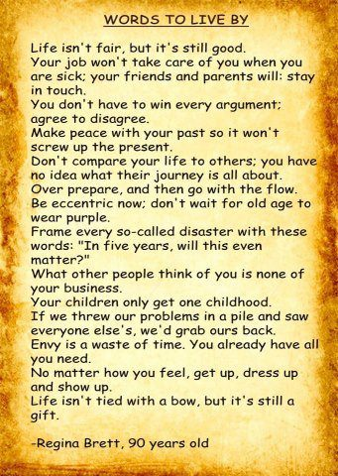

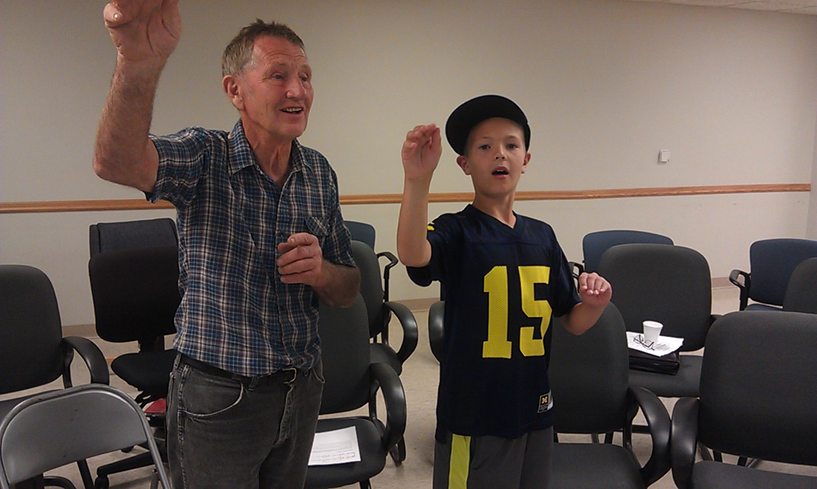
Karl Peterson & grandson directing “Keep the Whole Word Singing”
Our Chorus Mission:
The Indianhead Chorus is a fraternity of men drawn together by a love of singing, performing, and promoting four-part close a cappella harmony music known as barbershop.

Our Chorus Vision:
The Indianhead Chorus vision is to be a dynamic, high quality barbershop singing organization always striving for excellence.

Five Quartet Singing Talents

Some truths are unchanging. This 1963 piece by the legendary Lou Perry outlines the fundamental skills every quartet singer ought to possess.
We are all amateurs, which means we are doing something we love. We love to sing barbershop harmony. As Bob Johnson has stated on numerous occasions, most of us are not singers, but because we love to sing, we constantly strive to sing better so that eventually we may be able to sing for the pleasure of other people. Very often efforts toward this end result in men finally becoming singers. There is no better basis for the success of your quartet than this "best of all reasons for singing." There are other elements, however, which have an important part in determining how far your quartet can go. They are commonly referred to as talents, some of which we all have in varying degrees. They are discussed below in the order of their importance.
1. A musical ear
This talent involves the ability to mentally hear pitches, intervals and related musical sounds accurately. It does not imply any knowledge of musical theory or the ability to read music (visual identification). Like all talents, this one improves with practice so that reaction to pitch patterns is quickened. Unfortunately, a sensitive musical ear cannot be created.
If you do not have one, you had better take up golf or some like pastime. You do not belong in a singing society - unless of course you have remarkable administrative talents which might be used to implement the efforts of the singers.
2. Intelligence
Singing is primarily an exercise of the mind, not the body. Explaining singing in anatomical terms makes you think of anatomy instead of singing. Physical difficulties in singing are ones you put there yourself, such as strain, poor posture and abuse of the apparatus, etc. The only muscle not relaxed is the brain muscle. We use our innate intelligence to remove hurdles and to fortify our unique and individual strong points. Here is where intelligence is needed to concentrate on the job requirements of the various voice parts. We have to think about the sound being produced, and how this sound can best be made to come to the aid of the other three parties in this joint effort. We are called upon to weigh, balance, and make judgments in split seconds; to create ideas on the spur of the moment in order to keep a song alive; and to maintain the various tools we use under stricter discipline than in any other form of singing. We need to use our brains, gentlemen, every minute we are singing. As a lagniappe, the more we use them, the better they get, and we get, and singing gets. Singing without thought is mere sound, and even though generating sound is one of the most distinctive characteristics of our musical form, it is meaningless unless it is applied with conscious mental effort to the end of developing the idea of a song and making that idea great enough to share with an audience.
3. Vocal Equipment
Except for the lead, who should have some characteristics of what is usually referred to as a "voice," with strength, lyricism, and controlled vibrato for added color, the first two talents are more important. A good mind and ear can improve an average voice, but a voice with no guiding intelligence very often deteriorates. Voices in general are not fully formed until about age twenty-four. Young voices can be ruined for life by forcing them into a form they are not yet fitted for, especially in the lower registers. We should be most careful, then, to encourage interest in young people by letting them sing only material adapted to their capacities.
A good musical tone begins with the controlled expiration of breath in a balanced and relaxed body. The kind and quality of tone depends on what you mentally want to hear. Try singing a note at a comfortable pitch. Sing the same note another way. Which do you like better?
With practice, you can learn to make any kind of tone you want until, at will, you can furnish the sound that suits the current need of the quartet. In short, you set the standard of what you want to hear. The sound is you. By coincidence, the more you concentrate on the sound image, the ore relaxed you become and the better you sing. Very little of music was written to show off voices. What we can bring to music to better present the idea of the composer is the important thing, and because we love to sing, we will try to bring a well-disciplined tone, guided by intelligence.
4. A Sense of Rhythm
Because of the limited number of notes in the diatonic scale, there are only about a dozen basic melodies possible. (See "Sigmund Spaeth, Tune Detective.") These few melodies are made to sound like many different ones by stretching or compressing them over a variety of rhythmic patterns. In short,' rhythm’ gives the melody both form and motion. It may demand that we stay in one place, like soldiers marking time; or that we ride it forward on the melody, making the melody walk, dance, stroll, run, fly, and even fall down. The rhythmic pattern is named in the time signature. It tells what the basic pulsation will be. To a large degree, the bass in your quartet will decide when the pulsation must be pronounced or implied, regular or free, accelerated or retarded, according to the motion requirements of the song. The lack of rhythmic talent in a quartet makes for pedestrian songs. Coupled with a lack of talent number five below, a song can be stopped stone-cold dead.
5. Word Sense
Singing on vowels produces sound. Singing on words makes sound with meaning. Song lyrics are words put on notes to express an idea or tell a story. Barbershoppers sing songs, especially ones that tell stories. Might we not then more properly sing even exercises like scales and warm-up vocalizing on words as they are sung. The very least it could do would be to help loosen our tongues and relax our jaw muscles. The song lyric should be studied, analyzed, and learned to the point where we can visualize and describe the idea of it as a unit. We will thereby gain a better understanding of what attitude to take toward the notes themselves, no matter how low or high. The interpretation of a song is affected by the ability to read and understand the lyric. This "word-sense" cannot be taught as such. And, well it shouldn't for this is the area where individual personality has widest scope. A song is arranged according to the mental attitude toward the words. Phrasing, shading and emphasis, together with all other elements of interpretation, depend on this talent. The written arrangement is only the vehicle you use to make the song your own. When you succeed, the result is a great arrangement.
Conclusions
Find three other guys and get going! With the continued development and discipline of the above talents, a true barbershop quartet emerges, with a Style all its own. It will have a distinctive Sound, and will nurture an image reflecting the collective Taste inherent in its members.
Few quartets are fortunate enough to possess all the above talents to a high degree, which opens the door for outside help. The help might come from a voice teacher, a coach, a category judge-coach, a HEP team member or someone of goodwill who is knowledgeable enough to give you what you need without destroying what you have.
In closing, may I offer one other opportunity to quartets who decide to sing for the pleasure of other people. Listen for the effect on your audience while you are singing ... for attention, receptivity and empathy — instead of what they say or do after you have sung. Applause is not always the criterion of a good performance, but how sweet it is!

Prayer of St Francis –a song I learned in Amery HS Choir 50 years ago!

“Lord, make me an instrument of your peace.
Where there is hatred, let me sow love; Where there is injury, pardon;
Where there is doubt, faith; Where there is despair, hope;
Where there is darkness, light, and Where there is sadness, joy.
"O Divine Master, Grant that I may not so much Seek to be consoled as to console;
To be understood as to understand; To be loved as to love;
for it is in giving that we receive; It is in pardoning that we are pardoned;
and it is in dying that we are born to eternal life."

“50 Years from Now”
Three elderly gents were talking about what their grandchildren would be saying about them fifty years from now.
"I would like my grandchildren to say, 'He was successful in business,'" declared the first man.
"Fifty years from now," said the second, "I want them to say, 'He was a loyal family man.'" Turning to the third gent, he asked, "So what do you want them to say about you in fifty years?"
"Me?" the third one replied. "I want them to say, 'He certainly looks good for his age.'"
Do you need a procrastinator's creed?
You may wish to delay reading this until you have more free time. Here’s the creed:
1. I believe that if anything is worth doing, it would have been done already.
2. I shall never move quickly, except to avoid more work or find excuses.
3. I will never rush into a job without a lifetime of consideration.
4. I shall meet all of my deadlines directly in proportion to the amount of bodily injury I could expect to receive from missing them.
5. I firmly believe that tomorrow holds the possibility for new technologies, astounding discoveries, and a reprieve from my obligations.
6. I truly believe that all deadlines are unreasonable regardless of the amount of time given.
7. If at first I don't succeed, there is always next year.
8. I shall always decide not to decide, unless of course I decide to change my mind.
9. I shall always begin, start, initiate, take the first step, and/or write the first word, when I get around to it.
10. I will never put off tomorrow, what I can forget about forever.

Try these exercises for the Upper Range

They are gleaned from a Jim De Bussman vocal production article. I have also added some suggestions.
1. Use “warm air!” Breath in slowly thru your nose and mouth, filling the bottom of your lungs first, holding for 5 seconds, then exhaling warm air quietly and slowly thru your open mouth, gently controlling the air leaving your lungs by raising your diaphragm - keeping your throat open.
2. Add the following sound to the above exercise: zee - oo and zoo – ee. Go 5 seconds on the ee and oo, with a clean quick change to the next vowel sound, slight crescendo on the second vowel. Breath to stop the sound! Repeat each 5 times.
3. Sing a five tone descending scale (G above middle C) on “oo” Clean intervals, with a slight crescendo, hold the final "oo" for 5 seconds, breath to stop the sound. Repeat 3 times. Sing a small H in front of the first "oo" to start the warm air flowing - you can use the small H idea in vowel exercises

If pro is opposite of con, then what is the opposite of progress?
Congress!
Our Officers for 2012
President: Mark Nelson ……………………………… ……..715-483-3152
Sec/Treas: Larry Fisk …………………………………….. …715-327-8091
VP Marketing & PR & Bulletin editor: Ken Mettler……….....715-483-9202
VP Music: Gary Noren …...………………………………..……..715-483-9566
VP Membership: Harvey Sandahl ……………………………651-226-9687
Asst. Music Dir. & Webmaster: Karl Wicklund.………. ...…715-268-2685
Music Director: Steve Swenson…………………….…….….715-483-9797
Members at Lg.: Alan Salmela……………………………....715-472-4018
Archie Lessard………………….………….651-462-4664
Dan Valentine…………………….………..715-472-2080
Other functions
Young Men in Harmony: Jon Buss…..................715-410-7324
Birthday/Anniversary cards: Clint Gjerde
2012 Show Chair: Archie Lessard…………..…...651-462-4664
Librarian: Bryan Shobe
Performance Coordinator: Dan Valentine.….….715-472-2080

WHAT IS HAPPINESS?
To be happy with a man, you must understand him a lot and love him a little.
To be happy with a woman, you must love her a lot and not try to understand her at all.
Dare to Dream Great Dreams
Dreams not only give valuable personal insights but also have given many creative insights. Some inventors, for example, have received profound ideas from dreams. I recall reading how the inventor, Elias Howe, designed the first sewing machine. He was having great difficulty in conceiving a workable needle. When he was close to running out of money, he had an unusual dream. He dreamt that he was about to be executed because he failed to design a sewing machine for the king of a strange country.
In his dream he was surrounded by guards, all of whom held spears that had been pierced with holes near the tip. Howe woke up and immediately rushed to his workshop. The perfect concept for the sewing machine needle came to him in this dream. Within a few hours the first sewing machine design was well on the way to being completed.
I have heard it said that the theory of relativity came to Einstein in either a dream or a vision. Apparently he saw it on a beam of light. I have also read that the design for the first radio tube came to the inventor in a dream.
Think about dreams. Whether we repress them as many do, ignore them as most do, or use them for creative purposes as some do is entirely up to each individual.
If you want to remember your dreams, keep a pen and pad at your bedside and record any dream that makes a strong impression on your mind. Speaking personally, dreams have given me some valuable insights for growth.
AIDS WARNING!
To all of you approaching 50 or who have REACHED 50 and past, this note is especially for you... SENIOR CITIZENS ARE THE NATION'S LEADING CARRIERS OF AIDS: HEARING AIDS -BAND AIDS -ROLL AIDS -WALKING AIDS -MEDICAL AIDS -GOVERNMENT AIDS
MOST OF ALL, FINANCIAL AIDS TO THEIR CHILDREN!
Not forgetting HIV (Hair Is Vanishing

The 100/0 Principle by Al Ritter

Some people have accused me of suffering from insanity. But it's not true. I enjoy every moment of it.
What is the most effective way to create and sustain great relationships with others? It's The 100/0 Principle: You take full responsibility (the 100) for the relationship, expecting nothing (the 0) in return.
Implementing The 100/0 Principle is not natural for most of us. It takes real commitment to the relationship and a good dose of self-discipline to think, act and give 100 percent.
The 100/0 Principle applies to those people in your life where the relationships are too important to react automatically or judgmentally. Each of us must determine the relationships to which this principle should apply. For most of us, it applies to work associates, customers, suppliers, family and friends.
STEP 1 - Determine what you can do to make the relationship work...then do it. Demonstrate respect and kindness to the other person, whether he/she deserves it or not.
STEP 2 - Do not expect anything in return. Zero, zip, nada.
STEP 3 - Do not allow anything the other person says or does (no matter how annoying!) to affect you. In other words, don't take the bait.
STEP 4 - Be persistent with your graciousness and kindness. Often we give up too soon, especially when others don't respond in kind. Remember to expect nothing in return.
At times (usually few), the relationship can remain challenging, even toxic, despite your 100 percent commitment and self-discipline. When this occurs, you need to avoid being the "Knower" and shift to being the "Learner." Avoid Knower statements/ thoughts like "that won't work," "I'm right, you are wrong," "I know it and you don't," "I'll teach you," "that's just the way it is," "I need to tell you what I know," etc.
Instead use Learner statements/thoughts like "Let me find out what is going on and try to understand the situation," "I could be wrong," "I wonder if there is anything of value here," "I wonder if..." etc. In other words, as a Learner, be curious!
Principle Paradox
This may strike you as strange, but here's the paradox: When you take authentic responsibility for a relationship, more often than not the other person quickly chooses to take responsibility as well. Consequently, the 100/0 relationship quickly transforms into something approaching 100/100. When that occurs, true breakthroughs happen for the individuals involved, their teams, their organizations and their families.

Tips For Student Pilots
1. Takeoffs are optional. Landings are mandatory.
2. If you push the stick forward, the houses get bigger. If you pull the stick back, they get smaller.
3. Flying isn't dangerous. Crashing is dangerous.
4. It's always better to be down here wishing you were up there than up there wishing you were down here.
5. The only time you have too much fuel is when you're on fire.
6. The propeller is just a big fan in front of the plane used to keep the pilot cool. When it stops, you can actually watch the pilot start sweating.
7. When in doubt, hold on to your altitude. No one has ever collided with the sky.
8. A "good" landing is one from which you can walk away. A "great" landing is one after which they can use the plane again.
9. Learn from the mistakes of others. You won't live long enough to make all of them yourself.
10. You know you've landed with the wheels up if it takes full power to taxi to the ramp.
11. The probability of survival is inversely proportional to the angle of arrival. Large angle of arrival equals a small probability of survival -- and vice versa.
12. Never let an airplane take you somewhere your brain didn't get to five minutes earlier.
13. Stay out of clouds. The silver lining everyone keeps talking about might be another airplane going in the opposite direction.
14. Reliable sources also report that mountains have been known to hide out in clouds.
15. There are three simple rules for making a smooth landing.
Unfortunately, no one knows what they are.
16. You start with a bag full of luck and an empty bag of experience. The trick is to fill the bag of experience before you empty the bag of luck.
17. Keep looking around. There's always something you've missed.
18. If all you can see out of the windscreen is ground that's going round and round and all you can hear is commotion coming from the passenger compartment, things are not at all as they should be.
19. In the ongoing battle between objects made of aluminum going hundreds of miles per hour and the ground going zero miles per hour, the ground has yet to lose.
20. Good judgment comes from experience. Unfortunately, experience usually comes from bad judgment.
21. It's always a good idea to keep the pointy end going forward as much as possible.
22. There are old pilots and there are bold pilots. There are, however, no old, bold pilots.
23. Remember, gravity is not just a good idea. It's the law. And it's not subject to repeal.
24. Always try to keep the number of landings you make equal to the number of takeoffs you've made.
25. The three most useless things to a pilot are altitude above you, runway behind you, and a tenth of a second ago.
And a bonus tip:
Helicopters can't fly; they're just so ugly the earth repels them.
