
Barbershop Harmony Society, 110 7th Avenue N., Nashville, TN 37203-3704 www.barbershop.org
Land-O-Lakes District - LOL home page: www.loldistrict.org
1,000 Lakes Division –Probe Member
Our fifty-sixth year –November, 2013

Practice Monday, November 11th will be @ Luck Lutheran church at 7:30 PM

Our Show was a Success!

Thanks! To everyone who made this year’s Harvest of Harmony show a success. There are so many I’m sure I’d miss one or two important contributors if I’d try to name them all. It takes a lot of work and commitment from everyone to put on such a large program. The quartets were very entertaining and fun to watch and listen too. The crowd was happy with everyone’s performance and the script and actors were very good. So how do we top this year’s program? How do we get more singers on the stage and at practice? We do that by committing to put the effort into achieving the goals that we set every year. On November 2nd we will meet again to discuss items which will help us achieve these goals. Let’s put the energy and fore sight into these goals. The outcome will be a larger group of singers at our performances and our audiences will be rewarded. So let’s put the time and effort into making these goals. We’ll have a lot more fun singing then.
Thank You,
Archie Lessard

Happy Thanksgiving!

May your stuffing be tasty, may your turkey be plump,
May your potatoes and gravy, have never a lump.
May your yams be delicious, and your pies take the prize,
And for the women of the list -
May your Thanksgiving dinner stay off of your thighs!



BHS Army Mobilized -November 2013

23K/Phase II is underway — watch your email
Every day, up to 500 Society members will be receiving a personal email invitation to conduct their own "do-it-yourself" interview. Watch your email inbox for your own invitation. You can be assured it is legitimate if it comes from webmaster@bhsadmin.org and it takes you to a web page at <www.bhsadmin.org>. The entire process should take no more than 15 to 20 minutes. Please respond quickly when you get your
own personal invitation. The volunteer army needs your help, and our Society deserves our support.
Project 23K is the Barbershop Harmony Society initiative to identify volunteers for key projects to promote and grow the society. You are being invited to take an online survey of five questions and to then identify the skills you currently have that could help on a volunteer project. If you prefer, you may instead choose to be interviewed by telephone by one of our callers. This is a critical period in history of the Barbershop Harmony Society and through the help of skilled volunteers like you we expect to accomplish many projects. Sincerely, Project 23K Team, Chairman: Montana Jack Fitzpatrick

CODE OF ETHICS
The Society aspires to preserve for its members and for all future generations of members the sacred right of men to seek haven from the burden of their daily cares through indulgence in old-fashioned vocal quartet harmony, and to that end we do hereby solemnly pledge ourselves to abide by the precepts of the Code of Ethics.
 We shall do everything in our power to perpetuate the Society.
 We shall deport ourselves and conduct the Society’s functions in such manner as to reflect credit upon the Society and its membership.
 We shall conform in all aspects to the bylaws of the Society and the rules from time to time promulgated by its Society Board of Directors.
 We shall accept for membership only congenial men of good character who love harmony in music or have a desire to harmonize.
 We shall exhibit a spirit of good fellowship toward all members.
 We shall refrain from forcing our songs upon unsympathetic ears. We shall not use our membership for personal gain.
 We shall not use our membership in the Society for personal gain.
 We shall not permit the introduction of political, religious or other similar controversial issues into the affairs of the Society.
 We shall by our stimulus to good music and vocal harmony, endeavor to spread the spirit of harmony throughout the world.
 We shall render all possible altruistic service through the medium of barbershop harmony.

The idea of polygamy frightens me - all those mothers-in-law.
We wish you all a most gratifying and memorable Thanksgiving Day. There is so much we have to be thankful for, not only for God's unending blessings, but also for the affirmation and encouragement we have received from each other.
"Today upon a bus, I saw a lovely maid with golden hair; I envied her—she seemed so happy, and how, I wished I were so fair; When suddenly she rose to leave, I saw her hobble down the aisle; she had one foot and wore a crutch, but as she passed, a smile. Oh God, forgive me when I whine, I have two feet—the world is mine.
"And when I stopped to buy some sweets, the lad who served me had such charm; he seemed to radiate good cheer, his manner was so kind and warm; I said, 'It's nice to deal with you, such courtesy I seldom find'; he turned and said, 'Oh, thank you sir.' And then I saw that he was blind. Oh, God, forgive me when I whine, I have two eyes, and the world is mine.
"Then, when walking down the street, I saw a child with eyes of blue; he stood and watched the others play, it seemed he knew not what to do; I stopped a moment, then I said, 'Why don't you join the others, dear?' He looked ahead without a word, and then I knew he could not hear. Oh God, forgive me when I whine, I have two ears, the world is mine.
"With feet to take me where I'd go / with eyes to see the sunsets glow / with ears to hear what I would know / I am blessed indeed / The world is mine / oh, God, forgive me when I whine."^{source unknown}
This month we celebrate Thanksgiving Day…a day when friends and family all across this land will join together in a great day of feasting, but I cannot help but wonder how many of us will be truly thankful—I mean truly thankful to God for the abundant blessings he has given to those of us who live in free countries.
Have a warm and wonderful Thanksgiving!
Hope you enjoy the Monday night lunches!
I know you guys enjoy the lunches every Monday night. Let me take time right now to say “thanks” to everyone for helping with this part of our practice night. Charles Swindoll says, “Not enough is said about taste. Hunger and thirst may begin in our brains, prompting the digestive salivary enzymes to start flowing . . . but the satisfying part of the digestive process happens in the mouth. We have those tiny taste buds to thank for allowing us the pleasure of enjoying everything we eat and drink. Whether it be a cold, refreshing glass of lemonade on a hot summer day or a juicy, flavorful steak cooked on the backyard grill or a delicious bowl of spicy, homemade chili served with a dash of cheese and chopped onion or perfectly seasoned, fresh vegetables that crunch in our mouths, there are few pleasures more satisfying than slowly enjoying a well-prepared meal.
Don't rush too quickly past the keyword slowly. Food is meant to be savored, chewed slowly and thoughtfully . . . not wolfed down like a big croc ferociously gulping the hind leg of a zebra! When we choke down our food too quickly, we not only fail to chew it long enough, failing to break it down so that it can be properly absorbed into the body, but we also bypass one of the most delightful senses God created us to enjoy: taste. It's amazing how much food we can chew and swallow yet not take enough time to glean the satisfying benefits of lingering over its delicious taste.”
We would also do well to "savor the moment" while journeying through life. In other words, take the time to pause and enjoy life's significant scenes: touching the soft petals of a lovely English rose, watching a slowly descending sunset that explodes the sky with brilliant colors, enjoying the presence of a little child whose face radiates such innocence or a clumsy, playful puppy with floppy ears, listening to the thunderous surf as its powerful waves pound and foam, pondering the well-written lines of a book by a gifted author who ignites your imagination through carefully chosen words, singing an old favorite Barbershop song. With all those moments to savor, I suggest that we begin to savor the meal. Rushing through our food as if we had a flight to catch is a habit we need to break! Just as it takes time to think deeply, it takes time to taste deeply.

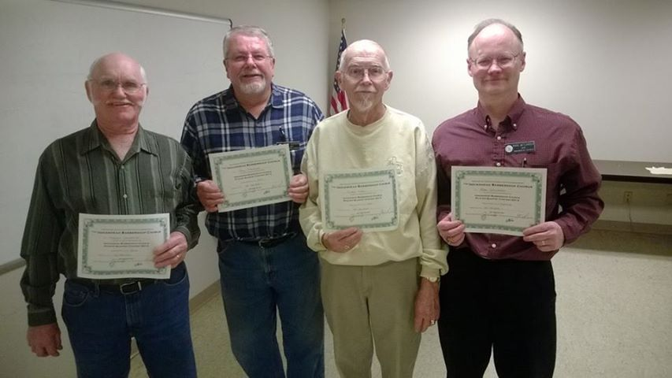
Recently we held a pick-up quartet contest. Congratulations to The Newbies +, the winning foursome: Harley Schafer, Bill Stevenson, Duane Morris and Mark Westlander!

