
Barbershop Harmony Society, 110 7th Avenue N., Nashville, TN 37203-3704 www.barbershop.org
Land-O-Lakes District - LOL home page: www.loldistrict.org
1,000 Lakes Division –Probe Member
http://indianhead.groupanizer.com
March, 2013 - Vol. 56, Issue 3

Events Calendar:

VLQ at Amery Nursing Homes on March 17, 2013, 2 PM
April – 75th Anniversary of the Barbershop Harmony Society
2013 Spring Convention & Intn’l Prelims -Roseville, MN -May 3-4, 2013
Osceola Sign-out is July 11th--5:30 PM Sing time
Chorus @ Luck Music in the Park is confirmed for August 6th
Wannigan Days is July 20th (Unconfirmed)
Church sing-outs in June and August
Our Show will be held in Amery, Rusty Pipes as a guest quartet - Oct 12, 2013
2013 Fall Convention & District Contest -LaCrosse, WI –Oct. 25 - 27, 2013

Our President’s Pointers!

I'm writing this from my deck in Cozumel. That's the reason this article is so short. The new show songs keep on rolling out. Yesterday in the airport my wife told me I am humming all the time. And of course it was one of the new songs. I enjoy singing so much it is my sane time in a busy week. No matter what our reason for singing is, it is our happy moment of the week. So let's come on Mondays and have a great time singing Barbershop!

See you on the return flight,
Archie Lessard, President

Here’s a recent Facebook posting--

Singing is so vital. I forget that when I don't sing - a lot - I become much less of a person. We need singing to remind ourselves of who we are. At least I do. -Stephanie Mettler

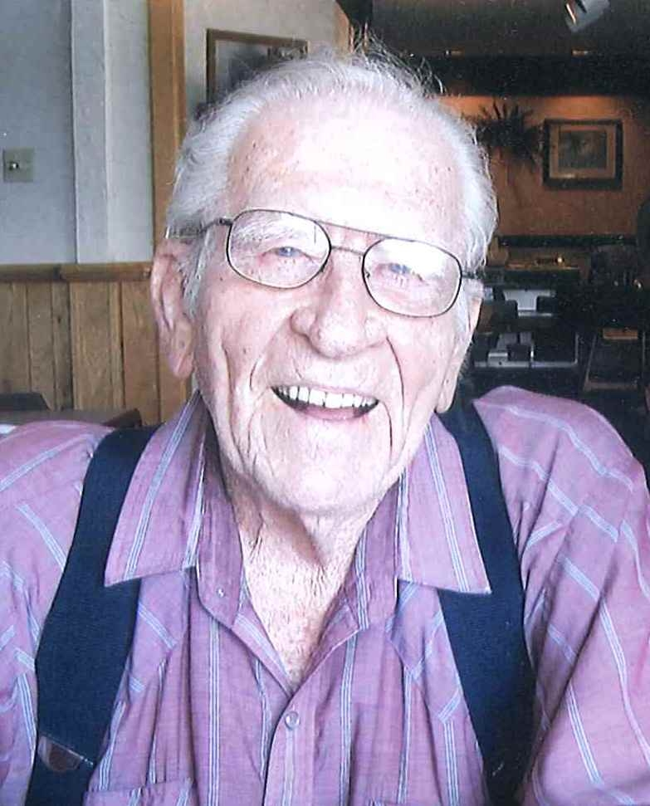
Thanks to the fellows who sang for Wayne Greenly’s funeral on Feb. 8th. Here (above) is Wayne in a recent photo and in a quartet many years ago.

Kaptain Karl’s Korner

Quick. What’s touching your hand right now?
Your cheek?
What about the back of your shoulder?
The inside of your ribs?

Chances are, it took just a moment longer to distinguish the sensation on your shoulder. I’d lay bets that you couldn’t say much about the texture of your lungs. Our sense of body tends to focus on our hands and face. Not surprising, since this is where we have the most nerve endings. (For an interesting, if grotesque, illustration of a person proportioned by the number of nerve endings, Google cortical homunculus.)

Lips and tongues are tremendously sensitive – not only because they touch and move every piece of our food, but because they need to precisely articulate each sound in every language. Speech and music come through our head; this is where we can feel it. We can feel the sound vibrating our skulls. Because of this, we sometimes have a tendency to think of our voice as coming mostly from our head. But you and I know there is much more to the story.

The diaphragm is a large muscle that pretty much cuts us in two at the lower ribs. This, and a few other associated parts, controls our breathing. When we singers are conscious of the mechanism, it makes it easier to sing with supported breath. But it’s hard to feel directly - most things buried in our guts aren’t touch sensitive. To get a sense of how the diaphragm engages, we’ve got to tune in to secondary cues – our breath, our balance, even the fit of our clothes.

That pesky diaphragm is important to quality singing, but so is the rest of the body. If we lock our knees, rest on our heels, cross our arms on our belts, we might be sort of sluggishly comfortable, but that translates to the rest of us. If the whole system isn’t online, the individual parts don’t operate like they could. And, because they are so short on those nerve endings, those other parts of the system are sometimes hard to keep track of.

The trick (oh, there’s always a trick, isn’t there?) is to consistently and consciously adjust our breathing and our posture until it becomes habit. So, quick, sit up, breathe deep and feel the music welling up from inside.

Be well!

Kaptain Karl, Assistant Director
defender of the poor / champion of the oppressed / advocate of the innocent / www.kaptainkarl.com

Recruiting ideas

I hadn't really thought about the "reason" for the successful recruitment of new members, but, upon some introspection, I am inclined to offer a few salient ideas which come to mind.
Most important of all is to treat each guest like he is your long-lost brother! Make sure, at all times that he has current music, knows where and when to sit; stand too, whatever at all times. We take so much for granted when we have guests. We assume that they know all there is to know about our wonderful hobby.
It is so easy to welcome them into our fold, then, at break time race off and sing with a quartet without so much as a nod to our guest(s). We should always assume that the guest wants to know as much as you are willing to spend time telling, showing him about your hobby. In other words, treat him as you would like to be treated. I am belaboring this point simply because of its extreme importance!
Secondly, you should assume that he wants to sing. Find out quickly what his range is and introduce him to a simple tag by getting two other guys to help, by teaching him his part and singing in a quartet! We continue to talk a great line about how quartet oriented we are, but, how many guests are given the time sometime during the evening to learn a tag and then, sing it in front of the chapter during some short break, maybe just for his pleasure! We are often awed by our brilliance at singing some complicated thing in the chorus which we have worked on for months in hopes of impressing our guests. I can tell you now that most of the guys I know get more out of a simple tag with 3 (not four) other guys than the best song produced by the greatest chorus! If the guy feels insecure, let him 5th wheel for a bit in a private area until he feels comfortable. Don't push him if he clearly feels uncomfortable. The key word is in our logo...ENCOURAGE. The rest is simple. Take him to the afterglow, buy him a drink, insist that he sing at least one more simple tag with a captive audience, and I can guarantee you, if he is a viable candidate, he will be hooked! Offer to pick him up next week (or find someone who lives close to him). Be sure to continue some portion of your attention after he has joined, or he will peg you for the phony you are, if all you wanted him to do was sing in the chorus.
Marv Ewing, Fullerton Chapter, CA
~~~~~~~~~~
I’m Half Joking here:
Not too long ago a large seminar was held for ministers in training.
Among the speakers were many well-known motivational speakers. I introduced a man who boldly approached the pulpit and, gathering the entire crowd's attention, said, "The best years of my life were spent in the arms of a woman that wasn't my wife!"
The crowd was shocked! He followed up by saying, "And that woman was my mother!" - The crowd burst into laughter and he gave his speech which, went over well.
About a week later one of the ministers who had attended the seminar decided to use that joke in his sermon. As he shyly approached the pulpit one sunny Sunday, he tried to rehearse the joke in his head. It seemed a bit foggy to him this morning. Getting to the microphone he said loudly, "The greatest years of my life were spent in the arms of another woman that was not my wife!"
His congregation sat shocked. After standing there for almost 10 seconds trying to recall the second half of the joke, the pastor finally blurted out "...and I can't remember who she was!"

“If you have a parrot and you don't teach it to say, ’Help, they've turned me into a parrot’, you are wasting everybody's time.”
Before And After Falling In Love
B - You take my breath away
A - I feel like I'm suffocating
B - She says she loves the way I take control of the situation
A - She called me a controlling, manipulative egomaniac
B - Lucy and Ricky
A - Fred and Ethel
B - Saturday Night Fever
A - Monday Night Football
B - He makes me feel like a million dollars
A - If I had a dime for every stupid thing he's done...
B - Don't stop
A - Don't start
B - The Sound of Music
A - The Sound of Silence
B - Is that all you're having?
A - Maybe you should just have a salad, honey.
B - Wheel of Fortune
A - Jeopardy
B – It’s like I'm in a dream
A – It’s like he's in a dorm
B - $60/dozen
A - $1.50/stem
B - Turbo charged
A - Jump start
B - We agree on everything!
A - Doesn't she have a mind of her own?
B - Charming and Noble
A - Chernobyl
B - Idol
A - Idle
B - I love a woman with curves
A- I never said you were fat
B - He's completely lost without me
A - Why won't he ever ask for directions?
B - Time stood still
A - This relationship is going nowhere
B - Croissant and cappuccino
A - Bagel and instant
B - Blind
A - Nearsighted
B - You look so seductive in black
A - Your clothes are so depressing
B - Iambic Pentameter
A - Blank Verse
B - Oysters
A - Fishsticks
B - I can hardly believe we found each other
A - I can't believe I ended up with someone like you
B - Passion
A – Ration
~~~~~~~~~~~~~~~~~~~~~~~
Minnesota became the 32nd state on May 11, 1858 and was originally settled by a lost tribe of Norwegians seeking refuge from the searing heat of Wisconsin’s winters.
Minnesota gets it's name from the Sioux Indian word "mah-nee-soo-tah", meaning, "No, really... They eat fish soaked in lye".
The state song of Minnesota is "Someday the Vikings will... Aw, never mind".
The Mall of America in Bloomington, Minnesota covers 9.5 million square feet and has enough space to hold 185,000 idiot teenagers yapping away on cell phones.
Madison, Minnesota is known as "the lutefisk capital of the world". Avoid this city at all costs.
"The Mary Tyler Moore Show" was set in Minneapolis, Minnesota, and was Mary's first real acting job since leaving the "Dick van Dyke Show. The show about a single woman's struggle to find happiness in the big city was originally titled "Life without Dick", but that was changed for some reason.
Downtown Minneapolis has an enclosed skyway system covering 52 blocks, allowing people to live, work, eat, and sleep without ever going outside. The only downside to this is that a Norwegian occasionally turns up missing.
Cartoonist Charles M Shultz was born in Minneapolis, Minnesota and grew up in St. Paul. He was the only artist to accurately depict the perfectly circular heads of Minnesota natives.
The Hormel Company of Austin, Minnesota produces 6 million cans of Spam a year, even though no one actually eats it. Spam is a prized food in Japan & Hawaii--Spam sushi!!
Minnesota license plates are blue & white and contain the phrase "Blizzards on the 4th of July - you get used to it."
Frank C Mars, founder of the Mars Candy Co. Was born in Newport, Minnesota . His 3 Musketeers candy bar originally contained three bars in one wrapper; each filled with a different flavor of nougat -chocolate, Spam and lutefisk.
Tonka trucks continue to be manufactured in Minnetonka, Minnesota, despite the thousands of GI Joe dolls killed by them annually in rollover accidents. No airbags, no seat belts. These things are deathtraps, I tell ya!
Author Laura Ingalls Wilder was raised at Walnut Grove, Minnesota, and was famous for writing the "Little House" series of books, as well as inventing the "Spam diet" which consists of looking at a plate of Spam until you lose your appetite, much like the "lutefisk diet".
The snowmobile was invented in Roseau, Minnesota so as to allow families a means of attending 4th of July picnics.
Minnesotans are distinguishable from Wisconsinites. The way to tell them apart is to ask if they voted for Mondale in '84.
*Now... it's up to you to forward this Smoke Signal to all your friends. If one of them does not forward it to others, he/she will be given an entrance pin to attend the Eelpout Festival in Walker, MN next February.

Cold is a relative thing
65° Arizonans turn on the heat. People in Minnesota plant gardens.
60° Californians shiver uncontrollably. People in Minnesota sunbathe.
50° Italian & English cars won't start. People in Minnesota drive with the windows down..
40° Georgians don coats, thermal underwear, gloves, & wool hats. People in Minnesota throw on a flannel shirt.
35° New York landlords finally turn up the heat. People in Minnesota have the last cookout before it gets cold.
20° People in Miami all die. Minnesotans close their windows.
0° Californians fly away to Mexico. People in Minnesota get out their winter coats.
10° below zero: Hollywood disintegrates. The Girl Scouts in Minnesota are selling cookies door to door.
20° below zero: Washington, D.C. runs out of hot air. (Ya think? Nah.). People in Minnesota let their dogs sleep indoors.
30° below zero: Santa Claus abandons the North Pole. Minnesotans get upset because they can't start the snowmobile.
40° below zero: ALL atomic motion stops. People in Minnesota start saying..."Cold enough for ya?"
50° below zero: Hell freezes over. Minnesota public schools will open 2 hours late.

Rooles for Correct Speling, Gramer and Useage

1. Don‟t abbrev.
2. Check to see if you any words out.
3. Be carefully to use adjectives and adverbs correct.
4. About sentence fragments.
5. When dangling, don‟t use participles.
6. Don‟t use no double negatives.
7. Each pronoun agrees with their antecedent.
8. Just between You and i, case is important.
9. Join clauses good, like a conjunction should.
10. Don‟t use commas, that aren‟t necessary.
11. Its important to use apostrophe‟s right.
12. It‟s better not to unnecessarily split an infinitive.
13. Never leave a transitive verb lay there without an object.
14. Only Proper Nouns should be capitalized.
15. a sentence should begin with a capital and end with a period
16. Use hyphens in compound-words, not just in any two word phrase.
17. In letters compositions reports and
things like that we use commas to keep a string of items apart.
18. Watch out for irregular verbs which
have creeped into our language.
19. Verbs has to agree with their subjects.
20. Avoid unnecessary redundancy.
21. A writer mustn‟t shift your point of view.
22. Don‟t write a run-on sentence you‟ve got to punctuate it.
23. A preposition isn‟t a good thing to end a sentence with.
24. Avoid clichés like the plague.
25. Correct spelling is of the utmost importince. Be carefull. Use your dictionery.
26. And one last aggravated assault on the language. It is wrong to say a twentyfive
year birthday, why is it correct to say a twenty-five year anniversary? If you
said either is correct, you must stay after school every day for the ret of your life.

Stress is a Choice by David Zerfoss

Is your to-do list keeping you up at night?
Do you feel like your stress is off the charts?
Here's something that'll stop and make you think: Did you know that your stress is really your choice?
Several years ago while listening to my pastor give a Sunday sermon, he spoke about how life is made up of a series of choices. It made me realize that my hectic professional and personal life was of my choosing. Therefore, a life of stress had become my choice.
Many of us hurry through life going from one place to the next, focused on conquering the next mountain, making the next deal, running the next errand, and believing we will never have enough time to do all the things we need to get done. Yet, there is all the time in the world if we just realize that we are the creators of this life we choose to live. That's right. Life is a series of choices and being free from stress is one of those choices.
Whether your business life is overly complicated or your personal life (or both), you have chosen this current system of chaos. The world is a tantalizing swirl of getting the next "fix," tempting us to fit more and more things, people and processes into our lives, personally and professionally. And because we are so busy being busy, it's easy to be lured into the fray, with our lengthy to-do lists. Yet, the greatest achievements have often come from the simplest of ideas and in the simplest forms.
To experience a simplified life, we first have to learn to slow down long enough to see through all the clutter. We need to realize that we are powerful magnets that attracted this life to ourselves—no matter what—good or bad.
Take out a blank sheet of paper and create the life you truly want to live—with less stress and complexity—one that is anchored by a clear sense of your unique and simple purpose.
Some can trace their family back 300 years, but can't tell you where their children are tonight.

Didn’t You Know?

ADULT -A person who has stopped growing at both ends and is growing in the middle.
BEAUTY PARLOR -A place where women curl up and dye.
CHICKENS -The only animals you eat before they are born and after they are dead.
COMMITTEE -A body that keeps minutes and wastes hours.
DUST -Mud with the juice squeezed out.
EGOTIST -Someone who is usually me-deep in conversation.
HANDKERCHIEF -Cold Storage.
INFLATION -Cutting money in half without damaging the paper.
MOSQUITO -An insect that makes you like flies better.
RAISIN -A grape with a sunburn.
SECRET -Something you tell to one person at a time.
SKELETON -A bunch of bones with the person scraped off.
TOOTHACHE -The pain that drives you to extraction.
TOMORROW -One of the greatest labor-saving devices of today.
YAWN -An honest opinion openly expressed.
WRINKLES -Something other people have, similar to my character lines.

Attitude is Everything -by Vicki Hitzges

I used to worry. A lot. The more I fretted, the more proficient I became at it. Anxiety begets anxiety. I even worried that I worried too much! Ulcers might develop. My health could fail. My finances could deplete to pay the hospital bills.
A comedian once said, "I tried to drown my worries with gin, but my worries are equipped with flotation devices." While not a drinker, I certainly could identify! My worries could swim, jump and pole vault!
To get some perspective, I visited a well-known, Dallas businessman, Fred Smith. Fred mentored such luminaries as motivational whiz Zig Ziglar, business guru Ken Blanchard and leadership expert John Maxwell. Fred listened as I poured out my concerns and then said, "Vicki, you need to learn to wait to worry."
As the words sank in, I asked Fred if he ever spent time fretting. (I was quite certain he wouldn't admit it if he did. He was pretty full of testosterone—even at age 90.) To my surprise, he confessed that in years gone by he had been a top-notch worrier!
"I decided that I would wait to worry!" he explained. "I decided that I'd wait until I actually had a reason to worry—something that was happening, not just something that might happen—before I worried."
"When I'm tempted to get alarmed," he confided, "I tell myself, 'Fred, you've got to wait to worry! Until you know differently, don't worry.' And I don't. Waiting to worry helps me develop the habit of not worrying and that helps me not be tempted to worry."
Fred possessed a quick mind and a gift for gab. As such, he became a captivating public speaker. "I frequently ask audiences what they were worried about this time last year. I get a lot of laughs," he said, "because most people can't remember. Then I ask if they have a current worry—you see nods from everybody. Then I remind them that the average worrier is 92% inefficient—only 8% of what we worry about ever comes true."
Charles Spurgeon said it best. "Anxiety does not empty tomorrow of its sorrow, but only empties today of its strength."

Our Officers for 2013
President: Archie Lessard…..……..……………….………….651-462-4664
Sec/Treas: Larry Fisk …………………………………….. …715-327-8091
VP Marketing & PR & Bulletin editor: Ken Mettler……….....715-483-9202
VP Music: Gary Noren …...………………………………..……..715-483-9566
VP Membership: Harvey Sandahl ……………………………651 437-7822
Asst. Music Dir. & Webmaster: Karl Wicklund.………. ...…715-268-2685
Music Director: Steve Swenson…………………….…….….715-483-9797
Members at Lg.: Alan Salmela……………………………....715-472-4018
Dan Valentine…………………….………..715-472-2080
Mark Nelson …………………… … ……..715-483-3152

Other chorus functions
Young Men in Harmony: Jon Buss…..................715-410-7324
Birthday/Anniversary cards: Clint Gjerde……….715-268-7875
2012 Show Chair: Archie Lessard…………..…...651-462-4664
Performance Coordinator: Dan Valentine.…...….715-472-2080
2013 Show Chairman: Karl Wicklund
Assistant: Chuck Williamson
Librarian: Brian Shobe
Music committee: Steve Swenson, Karl Wicklund, Gary Noren, Dan Valentine

