
Barbershop Harmony Society, 110 7th Avenue N., Nashville, TN 37203-3704 www.barbershop.org
Land-O-Lakes District - LOL home page: www.loldistrict.org
1,000 Lakes Division –Probe Member
http://indianhead.groupanizer.com
June, 2010. Vol. 53, Issue 6

Check out these Upcoming Events for Barbershopping!

June 13 – Church Sing-out in New Richmond, WI area
June – Show Quartet try-out month
June 17-20 – Youth in Harmony Camp in LaCrosse, WI
June 23 – Centennial Celebration in Milltown, WI at 6 PM
June 28-July 4 – International BHS Convention “Let Freedom Sing” in Philadelphia. Register at www.barbershop.org/philly or call 800/595-4849
August 10 – Music in the Park at Luck, WI
August 13 – Music on the Overlook in St. Croix Falls,WI
August – Church Sing-out TBA
October 9 – Harvest of Harmony at Unity School with
“Expedition” and “Four Man Fishin’ Tackle Choir”

Let’s eat! (Monday night lunch schedule):
June 7 –John Roeber, 14 –Harley Schafer, 21 –Duane Stone, 28 –Steve Swenson, July 5 –Dan Valentine, 12 –Rick VanArnum, 19 –Fred Weber, 26 –Karl Wicklund, Aug. 2 –Chuck Williamson, 9 –John Hertog, 16 –Pete Rupp, 23 –Al Stocker, 30 –Ken Muschinske, Sept. 6 –Loren Nelson, 13 –Alan Salmela, 20 –Gary Noren, 27 –Dave Wallace, Oct. 3 –Aaron French

Mark's Notes

On May 15th, the board and a handful of others met with a facilitator in order to ensure the continued livelihood and growth of the Indianhead Chorus. Elsewhere in this edition of the Smoke Signals, you'll find a summary of the meeting from that day. The task of the board is now to make sure that we follow through with all the good ideas and suggestions brought forward. We'll be keeping track of the progress on the strategies and goals from that meeting on a monthly basis. Thank you to the board for your dedication that day and as we go forward. And a special thank you to the non-board members who were present that day to give us additional ideas and help - Jon Buss, Earl Hillestad, and Duane Stone. Thanks also to Norm Osero of Dynatronix for providing us with an excellent meeting facility.

We're heading into our busy summer season. With church sing-outs right around the corner, then a group of summer sing-outs and activities, we'll be busy sharing our hobby with others on a regular basis. Please take a few minutes at home each week to review your music so we can spend rehearsal time putting together the best performances possible. It's a great time of year to enjoy ourselves and provide our audiences with some great entertainment. I'm looking forward to creating some wonderful barbershop experiences for us and our communities.

Mark Nelson, President
What is that Red-Head Mamma talking about?

Written by Irving Mills in 1924, the lyrics to “Nobody Knows What a Red-Head Mamma Can Do” refer to other songs of the era, and in one case a folk tale. Some of you have asked for an explanation of this show song, so I did some quick research (thank you, Wikipedia) to provide some insight. I hope this helps our understanding of the piece.

“She can draw rings ‘round a gal like Louisville Lou…” This references a hit song from 1923, by Jack Yellen & Milton Ager called ‘Louisville Lou (That Vampin’ Lady).’ Here is a set of lyrics from that song:

Well, her name was Louisville Lou,
And what that vamping baby could do!
She was the most love-making-est, the shimmy-shaking-est,
That this world ever knew.
She's got the kind of love that holds 'em,
Big, black eyes, and she rolls 'em.
Hot lips, what pips, and no more conscience than a snake's got hips.
And when she struts her feathers and plumes,
The porters drop their mops and their brooms,
You ought to see them trailin' her, inhaling' her perfume.
And even Deacon Jones, who's crippled and bent,
Pawned his crutch just to pay her rent.
Now, brother, here's my warning to you:
Keep away from Louisville Lou.

“She can draw rings round a gal like Hard Hearted Hannah, the vamp of Savannah, G. A.” This line from the song’s reprise also refers to an Ager & Yellen song, ‘Hard Hearted Hannah (The Vamp of Savannah)’ from 1924. Either Irving Mills was a big fan of Ager & Yellen, or their songs were such hits that Mills decided to ride their coattails. Here is a portion of the lyrics:

In old Savannah, I said Savannah,
The weather there is nice and warm!
The climates of a Southern brand,
But here's what I don't understand:
They got a gal there, a pretty gal there,
Who's colder than an Arctic storm,
Got a heart just like a stone,
Even ice men leave her alone!
They call her Hard Hearted Hannah,
The vamp of Savannah,
The meanest gal in town;
Leather is tough, but Hannah's heart is tougher,
She's a gal who loves to see men suffer!
To tease 'em, and thrill 'em, to torture and kill 'em,
Is her delight, they say,
I saw her at the seashore with a great big pan,
There was Hannah pouring water on a drownding man!
She's Hard Hearted Hannah, the vamp of Savannah, GA!

“She can make a Bluebeard feel mighty blue.” This comes from a folk tale (the most famous version was written down in the 1600s) about King Bluebeard who marries a beautiful young maiden.
Bluebeard is gracious and kind and handsome and rich and everything a fairytale prince should be (except for his otherworldly blue beard). After several days of happy marriage, Bluebeard is called away. He gives his wife a set of keys, and permission to enter every room, wardrobe, chest and cabinet in the castle, with the exception of a single closet. The young wife’s curiosity gets the best of her, and she opens the forbidden door, only to discover the murdered bodies of several women. Bluebeard returns, catches his wife in her transgression, and announces that he shall now murder her, too. He is merciless, and the young woman only escapes due to the timely arrival of her brothers.

So, whoever this Red-Head Mamma is, she’s far more cold and manipulative than Hannah and Lou, and could even make the heartless Bluebeard feel blue. Yet, according to the tag, the narrator is still going to make her his own. Such is love. Or at least love songs.
Karl Wicklund, Assistant Director
Remember our June Chorus Performances!

June 13th is the church sing out in the southern part of our territory (think expanded sound). Be sure to sign up for this one. It is amazing how this works out as we travel from church to church. This is due to great planning and timing. The first sing out I did with the chorus was a church sing-out. I didn’t know the music very well at all but leaned on the other basses and sang softly. Funny how some things never change. It is a fun time.
June 23rd (Wednesday) is the Milltown Fisherman’s and Centennial Celebration. We expect a large crowd. We are scheduled to start at 6 pm. Plan on being there whatever time we are told to be there. This performance is being billed as the Indianhead Choir performance in honor of Jack Overby. The location is Bering Park. The park is on Hwy. 35. Also scheduled that night are a pie and ice cream social, a beard and mustache contest, and a best era dressed contest. Some of us can dig into our closets and come up with something for era dressed contest☺!
Dan Valentine, Performance Coordinator

Library Lore:

Did you notice how many singers we had last week (5-24-10)? We were in the THIRTIES and wasn’t that more fun? I thought so, plus we increased our membership by 2. GREAT! BUT, do you know what’s happened? We now have to order a few copies of some songs. PLEASE check your music for extras. Following is a list of what we are currently using. Thanks.

REPERTOIRE SONGS FOR 2010
America the Beautiful Overlay Coney Island
Dear Hearts and Gentle People Hello, Mary Lou
I’m Sitting on Top of the World It’s a Good Day
Louise Simple Melody
A Son of the Sea There Goes My Heart
That Railroad Rag Ain’t-a That Good News
Go Tell It on the Mountain

NEW SHOW SONGS
I Want a Girl, Just like the Girl Little Pal
Toot, Toot Tootsie Alleluia
Nobody Knows What a Red Haired Side by Side
All Dressed Up With a Broken Heart Wonderful World

John Roeber, Librarian

Here’s Your Groupanizer Information!

If you haven’t done so already, please take some time and check out the Groupanizer website. You can get there by opening up your internet browser and typing the following into the address bar. http://indianhead.groupanizer.com This is a members only website were you can get information related to the following: Schedule of Events, Member Forums or Blogs, list of current songs with learning tracks, and many other options.

If you are set up, your log in will be your first initial of your first name and your full last name. (no spaces between them) and your password is: barbershop Please note that you can change your username and password at any time and you are encouraged to do so.

If you try to log in and can’t do so, please contact me. sosero@amerytec.com You may not be set up or I may need to take another look at your set-up and verify the information entered.

Once you get it and log on you need to click on “My Account” on the left side. After that, click on “Create your Profile.” At a minimum, please add your name and scroll to the bottom and click the drop down arrow on “Sections” and select the voice part you sing. Feel free to add anything else you would like as well…Then click Save.

For those of you already out on the site, please take some time and update your song status and your attendance status. Both can be updated through the Dashboard (the main page). For event attendance status click on “Update Your Attendance Plan” in the dark grey bar in the My Attendance Plan Block on the right side of the Dashboard (See picture). Find the event you want to update, Select Edit on the right side, Select your attendance plan in the drop down box just to the left of the edit button and click save.
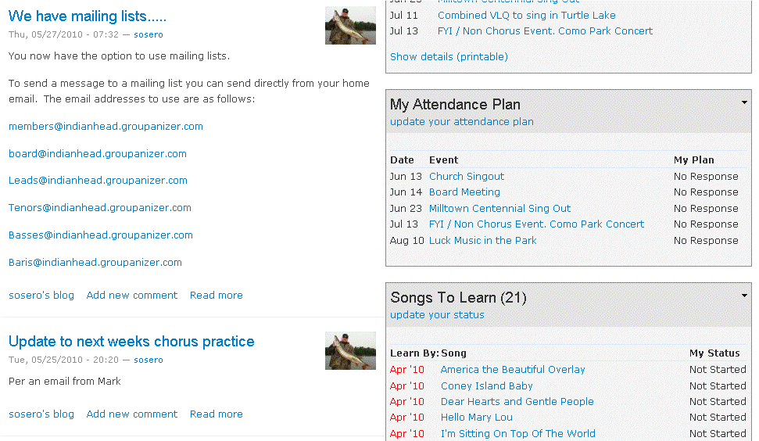

The song status update is also found on the Dashboard. Click “Update Your Status” in the “Songs to Learn” Block on the right side of the Dashboard (see Picture). Click “Edit” next to the song you want to update and select your song status for each song. Write a note in the “last comment” bar if need be….like…..Measure 47 we can’t seem to get….. Then click Save. This is a tool for the directors to use to help us organize our rehearsals better. If they are aware of which songs need the most work they can structure the rehearsals better. Note that only the directors will be able to see your song status.

To get at the learning tracks: First to get to the correct area on the website click Repertoire located on the top right of the screen. Now you should see a list of all of our songs. I have learning tracks available for the show songs and the old repertoire is coming in the near future.

Click on the song that you would like and scroll down to the list of links.

From here you have a couple of options.
1. Left click (normal selection with the mouse) on the link that you want to listen to and the .mp3 file will open up and play right in the website. It has to down load so it may take a little bit....hopefully not too long.

2. Another option..... Don't left click on the link.....right click instead and click save as or save link or something along those lines. From there you can select the location on your computer that you want it and you can choose to rename it if you choose. Once you have everything on your computer you can burn a CD. There are a lot of ways and programs out there that burn CDs....so I am at a loss for telling you how to do it on your specific computer.

The final option is to tell me that you need a copy and I'll burn one for you. We have one more song to introduce and that should hopefully be introduced next week. After that I plan on bringing my computer and some disks to chorus so I can burn them on the spot.

We will be having a training session in the near future on a Monday night some time. But in the mean time…..go out there and click around….you can’t hurt anything.

This is a valuable tool and I hope you will take advantage of it. I’ll say this again….that even though you can get all of your learning tracks out on the website….I am more than happy to burn a copy to a CD for you.

Steve Osero, Music VP

You Can Be Successful!
David Levenson has written a book titled, The Seasons of a Man's Life. In examination of the factors that contribute to the development, growth, and success of people, he discovered three primary factors that seem to be essential to success. The first is a great vision; a driving dream that moves and motivates you to do something with your life. Those who give themselves to the fulfillment of something worthwhile experience a great sense of accomplishment.
He said the second thing common to the successful people he studied was that they had each found a teacher who could instruct and help them along the way. Not only do we need a vision, we need some folks who have had visions before us, who can walk beside us and point the way.
There was another commonality among these successful people. They each had a deeply personal and significant relationship with at least one other person, someone who would support them in accomplishing their dreams. These were the folks who would walk with them through the difficult times; even when it seemed as though the dream would never come true. In short, they had a friend."²
We don't have to be famous to be successful … all we need is a vision, a good teacher, and a faithful, supporting friend. To this I would add that our vision needs to be in harmony with the chorus and a vital part of our purpose. So, here is our Chorus Mission Statement: “The Indianhead Chorus is a fraternity of men drawn together by a love of singing four-part, close acappella harmony music known as barbershop…” Our proposed vision statement is noted near the end of this publication. -ideas were gleaned from the book, Seasons of a Man’s Life and adapted. Note: For further information read, "You, too, Can Be a Winner" at: http://tinyurl.com/true-winner.

Take a minute for the minutes!

Membership: Motion and 2nd to accept Alan Salmela for membership. Motion carried.

Assistant Director: Karl said that chorus quartets will have tryouts in June to perform on the fall show. Contest songs are coming along with the help of coaching from Jim Emery and Gary Jacobson.
Show Chairman 2010: Motion and 2nd to leave the ticket prices the same as last year’s price at $8.00 Advance and $10.00 at the door. Motion Carried.
Audit: A motion passed to accept the chorus audit report.
Contest: Mark is taking care of all the details for the bus that the St. Croix Casino is furnishing for the trip to contest.
Chapter Planning Retreat: The retreat is May 15th at Dynatronix in Amery.
Scholarships: Motion and 2nd to give $800.00 to each Alice Greenlee and Nicole Larson as they have been chosen for this year’s scholarship recipients. Motion Carried.
Church Sing-outs: It was decided that the two areas for this summer’s church sing outs would be our southern-most area and northern Burnett county area. The first sing would be on the 13th of June. Earl Hillstad is organizing this.
Postings: It was suggested that the chorus have our Mission Statement posted at our regular rehearsals.
Groupanizer: The board has decided to sign up for a year to try it. Many things will be available for members such as learning new songs, news items, photos, and much more. All songs on the website are in an MP3 file.

Larry Fisk, Secretary

Our Officers for 2010
President: Mark Nelson ……………………………… ……..715-483-3152
Sec/Treas: Larry Fisk ……………………………………. …715-327-8091
VP Marketing & PR & Bulletin editor: Ken Mettler…...…….715-483-9202
VP Music: Steve Osero…...……………………………………...715-268-8146
VP Membership: Clint Gjerde ……………………….………715-268-7875
Asst. Music Dir. & Webmaster: Karl Wicklund.…….…….…715-268-2685
Music Director: Steve Swenson…………………….…….….715-483-9797
Members at Lg.: Larry Durand ..…………………….……….715-263-2201
Roger Johnson……………………….…….715-825-4393
John Roeber……………………………….715-472-6164

~~~~~~~~~~~~~~~other functions~~~~~~~~~~~~~~~~~~~
Young Men in Harmony: Jon Buss…...............715-246-3074
Birthday/Anniversary cards: LeRoy Brown.…..715-857-5422
Chapter Historian: Gary Merchant……………715-646-9396
2010 Show Chair: Ken Mettler……………….715-483-9202
Librarian: John Roeber …………………….…715-472-6164
Performance Coordinator: Dan Valentine…...715-472-2164

It only takes a few minutes!

Jim Rohn says, "You can cut down a tree with a hammer, but it takes about 30 days. If you trade the hammer for an ax, you can cut it down in about 30 minutes, and with a chain saw in about three minutes.”¹ The difference between 30 days and 30 minutes and 3 minutes is skills. The lesson: having the right tools for the job is a big help!

On the other hand, it may take 30 years or more to replace that tree. The lesson: we need to be extremely careful before we start cutting down anything of value as we may never be able to replace it. Like blow upon blow of a sharp axe, blow upon blow of cutting words can hurt deeply, ruin a marriage, severely damage a friendship, and destroy the self-concept of a child! -Cited in "Quotes From the Masters."

The Italian Secret to a Long Marriage

At St. Mary's Catholic Church they have a weekly husbands' marriage seminar.

At the session last week, the priest asked Giuseppe, who said he was approaching his 50th wedding anniversary, to take a few minutes and share some insight into how he had managed to stay married to the same woman all these years.

Giuseppe replied to the assembled husbands, "Wella, I've tried to treat her nicea, spenda da money on her, but besta of all is, I tooka her to Italy for the 25th anniversary!"

The priest responded, "Giuseppe, you are an amazing inspiration to all the husbands here! Please tell us what you are planning for your wife for your 50th anniversary?"

Giuseppe proudly replied, "I'm agonna go get her."

"AAAhhhhhhhhhhh!"

You've undoubtedly read about the father and son who were hiking in the mountains, but it stands repeating. You may have had the same experience as they had.
As they were walking along the son falls, hurts himself, and screams: "AAAhhhhhhhhhhh!"
To his surprise, he hears the voice repeating, somewhere in the mountain: "AAAhhhhhhhhhhh!"
Curious, he yells: "Who are you?"
He receives the answer: "Who are you?"
Angered at the response, he screams: "Coward!"
He receives the answer: "Coward!"
He looks to his father and asks: "What's going on?"
The father smiles and says: "My son, pay attention." And then he screams to the mountain: "I admire you!"
The voice answers: "I admire you!"
Again the man screams: "You are a champion!"
The voice answers: "You are a champion!"
The boy is surprised, but does not understand.
Then the father explains: "People call this ECHO, but really this is LIFE. It gives you back everything you say or do.
How true this is. Our life is pretty much a reflection of our actions. If you want more love in the world, create more love in your heart. If you want more competence in your team, improve your competence. This relationship applies to everything in all aspects of life—life will give you back everything you have given to it.
Your life is not a coincidence. It is a reflection of you.
-Author unknown; taken from the internet.

The LOL District Barbershopper of the Year award went to John Plazek, a Milwaukee Barbershopper who has a long record of service and accomplishments in our LOL District over the years. Most recently he has been overseeing the operations of the Mini-HEP School to be held in La Crosse in June.

Our Planning Meeting Produced Results!

On May 15, 2010 we had our chapter planning and visioning meeting in Amery. We would like to extend a special thanks to Norm Osero for the use of his building for the day. Mark introduced Lorraine Anderson who facilitated the discussions of the day. Mark gave a presentation on some of our chorus statistics in recent years. Lorraine had us break up into groups to discuss "what we want to be known for." The list was quite lengthy when we put all the ideas together. Then she gave us each three votes, and we were to vote for our top ideas. The ones that received the most votes were: "dynamic, energetic organization", "high quality singing organization", "promoting barbershop music", and "average guys shooting for excellence."
From there, we went on to create a vision statement, as well as outline some goals as to how we want to get there.

When our work for the day was completed, we had a revised Mission Statement, a Vision Statement, and the framework to work on some goals.

Our mission is why we exist. Our revised Chorus Mission Statement (still to be approved by the board) is: “The Indianhead Chorus is a fraternity of men drawn together by a love of singing, performing and promoting four-part, close acappella harmony music known as barbershop."

Our values declare who we are. One of the values we have is preserving our barbershop harmony style. However, we haven't really delineated a list of all of our values at this time.

Our vision is what we want to be. Putting our top ideas into one sentence was our goal, and here is what we said: Our Proposed Chorus Vision Statement: "Our vision is to be a dynamic, high quality Barbershop singing organization, always striving for excellence."

The following points were made:
We must own our vision, complete our vision, and maintain the focus of our vision. Our vision must push us and stretch us.
Our vision must drive our plan of action and our goals.
How we get there is our next objective.
Vision without action is a daydream.

Our top three goals to achieve our vision are to:
1. Create a more effective recruitment & growth plan.
2. Create a more effective rehearsal time.
3. Create a more effective chorus marketing plan.
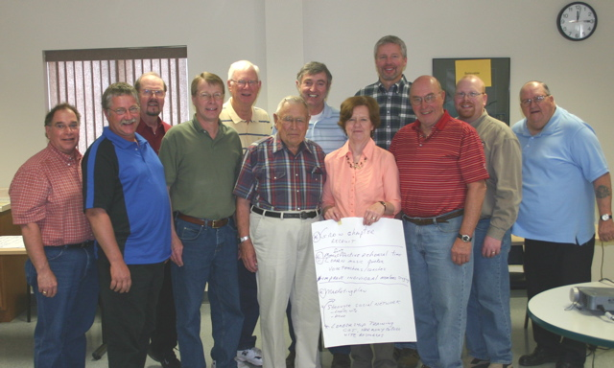

Listen to the 2009 International Championship Ambassadors of Harmony on You-tube!
http://www.youtube.com/watch?v=QmDGntpZC3I

How are we fixed for doe, rae, me?
Date | Fund |  |  |  | Balance
4/1/2010 | Operating Fund |  |  |  | $68.34
 |  | Income: |  |  | $ .51
 |  | Expenses: |  |  | 737.39
4/30/2010 | Operating Fund |  |  |  | (668.54)
4/30/2010 | YIH Festival |  |  |  | 6,429.01
4/30/2010 | Uniform Fund |  |  |  | 3,058.34
4/30/2010 | Performance Fnd |  |  |  | 1,000.00
4/30/2010 | Equipment |  |  |  | 939.58
4/30/2010 | Quartet Fund |  |  |  | 1,000.00
 | Quartet Fund |  | CD |  | 5,000.00
4/1/2010 | Social Fund |  |  |  | 351.72
 |  | Income: |  |  | 46.56
 |  | Expenses: |  |  | -
4/30/2010 | Social Fund |  |  |  | 398.28
 | Total of All Funds |  |  |  | 17,156.67
 |  | Total Committed Funds | $ -
 |  | Total Uncommitted Funds |  |  | $ (668.54)

Enjoy the little things,
for one day you will look back
and realize
that they were the big things!

