
Barbershop Harmony Society, 110 7th Avenue N., Nashville, TN 37203-3704 www.barbershop.org
Land-O-Lakes District - LOL home page: www.loldistrict.org
1,000 Lakes Division –Probe Member
http://indianhead.groupanizer.com
July, 2012 - Vol. 55, Issue 7

Events Calendar:
* July 1-8 –International Convention in Portland, OR
* July 12th –Mill Pond Park, Osceola, WI -7 PM (summer uniform)
* August 7 –Music in the Park, Luck WI -6:30 PM (summer uniform)
* August 11 –Threshing Days in Almelund, MN
* August 12 –Barbershoppers sing @ Twins vs. Rays game
* Aug 19 –Church Sing- Minnesota Churches
* Aug 19 –Chorus Social after church sing @ Archie Lessard’s home.
* Oct 13 –Amery High School- 54th Harvest of Harmony- 2 PM & 7:30 PM
* Oct 26 & 27 –District Contest, Rochester, MN

VLQ News-
For our new members the VLQ (Very Large Quartet) is made up of guys who desire to perform more. These guys have the time to come an hour earlier and to give up a Saturday or Sunday to perform at nursing homes and assisted living homes. The nursing home performances will start in the fall. I am hoping to use the VLQ to help promote the fall show at various locations TBA. Membership is open to all; we just ask that you attend practices. We are trying to use songs that are not on the chorus rep list. There are VLQ competitions and there are limits to the size that can compete on stage. We work all that out before hand. The summer weekends are filling up, but I still hope to show up at some farmer markets to promote the chorus and the show. The next performance on the schedule for the VLQ is Saturday, August 11th 2012 at the threshing show in Almelund, MN.

Dan Valentine

Its Summer time and the singing is Frequent...

Thanks to all who sang at St. Croix Falls and Milltown last week. We put together a couple of nice performances. Though the Milltown turnout was small, it was a well balanced group. Special thanks to Dan for his organizing of all of our performances, and for his MC work.

And now we have many other opportunities, including Osceola, Luck, churches in Minnesota, Twins game - to name a few. The church singout is slated for Minnesota with a picnic at Archie's place outside of Wyoming. That occurs on August 19th, and families are encouraged to attend. We'll have a sign up sheet out soon, but get it on your calendars.

Also of importance is to sign up for the fall Land O' Lakes District contest in Rochester on October 27th. The convention runs from the 26th through 28th, and there will be lots of other opportunities to enjoy our hobby beyond our singing on stage. The board needs to know soon whether or not we will be competing, and we don't know if we can compete until we see what our attendance will be.

It's a great time of the year for the chorus. Let's take advantage of it.

Mark Nelson, President

SMILE-
The music committee is trying to work out a way for us to see how we look when we are singing. I reviewed the Milltown performance recording and we didn’t look too happy, including me. What’s up with that?! Just like taking the first breath and leaning just a bit forward or remembering to energize at the end of phrases, we need make the performance face a habit. When I practice the songs and sing with the learning track, I try to practice the performance face for that song so it becomes just a part of the song just like the notes. It is work and I have not come close to perfecting it. Some of us have better faces for smiling than others but we all smile.
The committee is working on getting the visual coach from, the soon to be gold medal, The Great Northern Union Chorus to coach us. If I shout out “SMILE” or “LIGHT IT UP” it is just a reminder to turn on the performance face. If I become overbearing and obnoxious – get over it and smile darn you smile!
--Hey, we should learn that tag!

Dan Valentine, Music Committee

Membership Report

During the last few weeks, your efforts have added three new members to the chorus.
Welcome to Bill Stevenson, Brian Shobe, and Mic Larsen.
Also, our guest night on May 7 was a success. Three potential members attended the rehearsal to discover what barbershop singing is all about.
Thank you to everyone for the great turnout at our rehearsal and the support of our guests. I noticed everyone was engaged in conversation with our guests. It is good to see all members interacting with new people proving we are a friendly group.

Speaking of friendly, do you still have chorus business cards to hand out? If you need some additional cards, let Archie Lessard know as he has graciously offered to print more for chorus members as needed. We need to continue showing our presence and who we are in our communities. One way to do this is through handing out business cards.

Our Barbershop Harmony Society’s theme for 2012 is “Operation Harold Hill” which is a renovation of a successful membership growing program several years ago. Our group has also adopted this theme so the Society has delegated a Harold Hill representative to aid us in our goal of adding new members. In his conversation with us, he encouraged us to use this program to attract new members. Plus, he shared that his chapter is attracting new members by offering informal singing sessions at a local restaurant immediately after the scheduled chapter rehearsals. After a few times, word got out in the community and people came to the restaurant to listen… and new members began to participate.

A new idea for membership may come from anyone of us and it only takes one idea to attract members and watch membership growth. As your membership vice president, I am ready to listen to you and bring your ideas for increasing membership to our leadership.
All ideas are worth considering; think outside of the box!

Harvey Sandahl, Membership VP

Karl’s notes:

Quartet try-outs for the show will be July 2nd and July 9th during Monday night practice. Here is the procedure as approved by the board: Each quartet will sing for the chorus. A simple ballot will be given to the men at chorus; the 3 highest scoring quartets will be on the show. Quartets may sing on either the 2nd or the 9th, but not both. Quartets do not need to sing their proposed show song. A skillfully sung polecat or rep song is great. Substitutes are not encouraged, but are OK if there are no other options. (So, for instance I'm standing in for Jon Buss because he's out of town for the whole month.)

Please spread the word to those who may not receive this email. I know of at least four quartets trying out: Chariots, Bright Knights, Straight to Harmony and an Amery quartet whose name I do not know. Are there others? I'd appreciate it if a representative of each quartet would confirm that you received this information? Thank you!

ALSO, if you're not in a show quartet, don't forget that our afterglow is a great chance to sing for an enthusiastic audience! It just takes you and three other guys.
Karl Wicklund, Assistant Director
*I have a few more learning CDs. All of the learning tracks for 2012 show songs have been posted on Groupanizer.

Judging the Music Category
Judges in this category adjudicate the musical elements in the performance: melody, harmony, range and tessitura, tempo and rhythm and meter, construction and form, and embellishments. They judge the extent to which the musical performance displays the hallmarks of the barbershop style, and the degree to which the musical performance demonstrates an artistic sensitivity to the music’s primary theme.

Judging the Presentation Category
These judges evaluate how effectively a performer brings the song to life. They respond to both the visual and vocal aspects of the presentation, to evaluate the interaction of these aspects in creating the image of the song, as well as everything about the performance that contributes to emotional impact upon the audience.

Judging the Singing Category

Judges in this category evaluate the degree to which the performer achieves artistic singing in the barbershop style: the production of vibrant, rich, resonant, technically accurate, and highly skilled sound, created both by the individual singer’s use of good vocal techniques, and by the ensemble processes of tuning, balancing, unity of sound and precision. They listen for a sense of precise intonation, a feeling of fullness or expansion of sound, a perception of a high degree of vocal skill, a high level of unity and consistency throughout the performance, and a freedom from apparent effort that allows the full communication of the lyric and song. Each judge may award up to 100 points per song. Whether you aim for the gold, or want an objective benchmark of your abilities from year to year, the Contest and Judging system helps everyone get more from the hobby. All competitors are scored in three categories, Music, Presentation, and Singing. Expanded information can be found in the C&J Handbook



I was asked to write a little something to give the group some idea of my musical background. This should be short. I have few regrets but one of them is that I did not take up singing at an earlier age. I should have gone out for choir rather than football in high school. My wife always had been involved with church choirs, so when we got married she talked me into giving it a try. I have been a member ever since. I always figured my wife and I amounted to one decent tenor. She could reach the high notes that were beyond me and I could reach the low notes out of her range. I had a better sense of rhythm and she was better at finding the proper pitch. As you might imagine, this does not make me much of a solo singer. One of my goals as a member of this group is that I can develop into more of a complete singer. I have always enjoyed listening to harmonizing groups. When Steve Swenson invited me to join, it did not take much convincing. Recruitment seems to be an emphasis of the group, so if you have the feeling someone might be interested, have the courage to ask. The biggest challenge to me at this point is memorizing all or at least some of the music so I can participate in the performances. I have found the group to be very welcoming and that makes the transition from “newby,” to functioning performer much easier. Please have patience, and remember that sincere support goes a long way in building my confidence as a singer.
Bill Stevenson

Bob Hope quotes: I still chase women, but only downhill.
When I was born, the doctor said to my mother, “Congratulations, you have an eight pound ham.”

Scout's Letter Home
Dear Mom,
Our scout master told us all write to our parents in case you saw the flood on TV and worried. We are OK. Only 2 of our tents and 4 sleeping bags got washed away. Luckily, none of us got drowned because we were all up on the mountain looking for Jeff when it happened. Oh yes, please call Jeff's mother and tell her he is OK. He can't write because of the cast. I got to ride in one of the search & rescue jeeps. It was neat.
We never would have found him in the dark if it hadn't been for the lightning. Scoutmaster Web got mad at Hector for going on a hike alone without telling anyone. Hector said he did tell him, but it was during the fire so he probably didn't hear him. Did you know that if you put gas on a fire, the gas can will blow up? The wet wood still didn't burn, but one of our tents did; also some of our clothes. Larry is going to look weird until his hair grows back.
We will be home on Saturday if Scoutmaster Webb gets the car fixed. It wasn't his fault about the wreck. The brakes worked OK when we left. Scoutmaster Webb said that a car that old you have to expect something to break down; that's probably why he can't get insurance on it. We think it's a neat car. He doesn't care if we get it dirty, and if it's hot, sometimes he lets us ride on the tailgate. It gets pretty hot with 10 people in a car.
He let us take turns riding in the trailer until the highway patrolman stopped and talked to us. Scoutmaster Webb is a neat guy. Don't worry, he is a good driver. In fact, he is teaching brother Doug how to drive. But he only lets him drive on the mountain roads where there isn't any traffic. All we ever see up there are logging trucks.
This morning all of the guys were diving off the rocks and swimming out in the lake. Scoutmaster Webb wouldn't let me because I can't swim and Jeff was afraid he would sink because of his cast, so he let us take the canoe across the lake. It was great. You can still see some of the trees under the water from the flood. Scoutmaster Webb isn't crabby like some scoutmasters. He didn't even get mad about the life jackets. He has to spend a lot of time working on the car so we are trying not to cause him any trouble.
Guess what? We have all passed our first aid merit badges. When Rob dove in the lake and cut his arm, we got to see how a tourniquet works. Also Bruce and I threw up. Scoutmaster Webb said it probably was just food poisoning from the leftover chicken, he said they got sick that way with the food they ate in prison. I'm so glad he got out and become our scoutmaster. He said he sure figured out how to get things done better while he was doing his time.
I have to go now. We are going into town to mail our letters and buy bullets.
Don't worry about anything. We are fine.
Love, Dave

The Eight Points of Fun

An outstanding chapter meeting will vary from chapter to chapter. Consider your chapter's mission statement and goals and develop meetings that support them. Plan and organize chapter meetings so that all members enjoy the widest variety of activities that will result in a congenial, fraternal and educational experience.
The type of activities provided will depend on your chapter's mission and goals. Below are the basic elements recommended that can contribute to the overall enjoyment and quality of a chapter meeting. Experiment and learn what works best for your chapter. Bari Courts gives these points:
Vocal warm up
Open the meeting and prepare each man physically and mentally to sing. It should last no longer than 15 minutes and should be led by the most capable vocal technician in the group.
Gang singing
Barber polecat songs, old repertoire, tags: just "fun" singing.
Craft
Provide basic musical information, special lessons to be learned or barbershop history and lore to be investigated. Craft also is a constant thread during the rehearsal segment.
Break
This is Important as a period of relaxation and social interaction; also a good time to try a tag or sing with a guest.
Quartet activity
Quartets are a vital part of every meeting: Informal quartetting, registered quartets, intra or inter-chapter competition. Just get the guys singing with three other men. Having experienced men sing with those of lesser experience can benefit the quality of chorus singing.
Woodshedding
Everyone needs some great ear training. Music and tapes are available to get this activity started if you don't have an experienced woodshedder to lead the segment.
Business meeting
Keep it short. Introduce guests and make only necessary announcements of late-breaking changes in plans or upcoming events. Print an information sheet to eliminate lengthy discussions.
Chorus rehearsal
This is the major portion of the chapter meeting. It includes, learning new songs, section rehearsals, polishing the repertoire and other musical activities. A substantial part of the rehearsal should be held on the risers, practicing performance. Well, there it is... the eight points of fun. How many is your chapter currently using? ♫
-borrowed from Steve Jackson

Our Officers for 2012
President: Mark Nelson ……………………………… ……..715-483-3152
Sec/Treas: Larry Fisk …………………………………….. …715-327-8091
VP Marketing & PR & Bulletin editor: Ken Mettler……….....715-483-9202
VP Music: Gary Noren …...………………………………..……..715-483-9566
VP Membership: Harvey Sandahl ……………………………651-226-9687
Asst. Music Dir. & Webmaster: Karl Wicklund.………. ...…715-268-2685
Music Director: Steve Swenson…………………….…….….715-483-9797
Members at Lg.: Alan Salmela……………………………....715-472-4018
Archie Lessard………………….………….651-462-4664
Dan Valentine…………………….………..715-472-2080
Other functions
Young Men in Harmony: Jon Buss…..................715-410-7324
Birthday/Anniversary cards: Clint Gjerde
2012 Show Chair: Archie Lessard…………..…...651-462-4664
Librarian:
Performance Coordinator: Dan Valentine.….….715-472-2080

Fuel up before firing up!

An amusing thing happened on one occasion in the renowned Rose Parade in Pasadena in Southern California. One beautifully decorated float suddenly came to a standstill. It ran out of fuel!
The irony was that this float was entered by and represented the Standard Oil Company—one of the large fuel companies of North America. With all their vast oil and gasoline (petrol) resources, they failed to make sure their own vehicle was running on full.

Performances also require proper fuel: Rest, food, liquid and exercise all go together to make you a better singer. With them you won’t run out of energy, breath and creative genius! I know I’m preaching to the choir, but, I’ve been on the guilty side of this once too often. We all need to remember to fuel up before firing up to sing!
Yesterday Computer Song

Do you know the song "Yesterday"? Then sing along to this computer version.
Yesterday, all those backups seemed a waste of pay.
Now my database has gone away. Oh I believe in yesterday.
Suddenly, there’s not half the files there used to be;
And there's a milestone hanging over me. The system crashed so suddenly.
I pushed something wrong. What it was I could not say.
Now all my data's gone and I long for yesterday-ay-ay-ay.
Yesterday, the need for back-ups seemed so far away.
I knew my data was all here to stay; now I believe in yesterday.

English lesson

Lexiphiles -"lovers of words"-- you know, like “you can tune a piano, but you can't tuna fish”, or,” I wondered why the baseball was getting bigger . . . then it hit me”, etc..
When fish are in schools they sometimes . . . take debate.
A thief who stole a calendar . . . got twelve months.
When the smog lifts in Los Angeles . . U.C.L.A.
The professor discovered that her theory of earthquakes . . . was on shaky ground.
The batteries were given out . . . free of charge.
A dentist and a manicurist married . . . They fought tooth and nail.
A will is a . . . dead giveaway.
If you don't pay your exorcist . . . you can get repossessed.
With her marriage, she got a new name . . . and a dress.
Show me a piano falling down a mineshaft and I'll show you . . . A-flat miner.
You are stuck with your debt if . . . you can't budge it.
Local Area Network in Australia: the LAN down under.
A boiled egg is . . . hard to beat.
When you've seen one shopping center . . . you've seen a mall.
Police were called to a day care where a three-year-old was . . . resisting a rest.
Did you hear about the fellow whose whole left side was cut off? . . . He's all right now.
If you take a laptop computer for a run you could… jog your memory.
A bicycle can't stand alone; . . . it is two tired.
In a democracy it's your vote that counts; in feudalism . . . it’s your Count that votes.
When a clock is hungry... it goes back four seconds.
The guy who fell onto an upholstery machine . . . was fully recovered.
He had a photographic memory . . . which was never developed.
Those who get too big for their britches will be . . . exposed in the end.
When she saw her first strands of gray hair . . . she thought she'd dye.

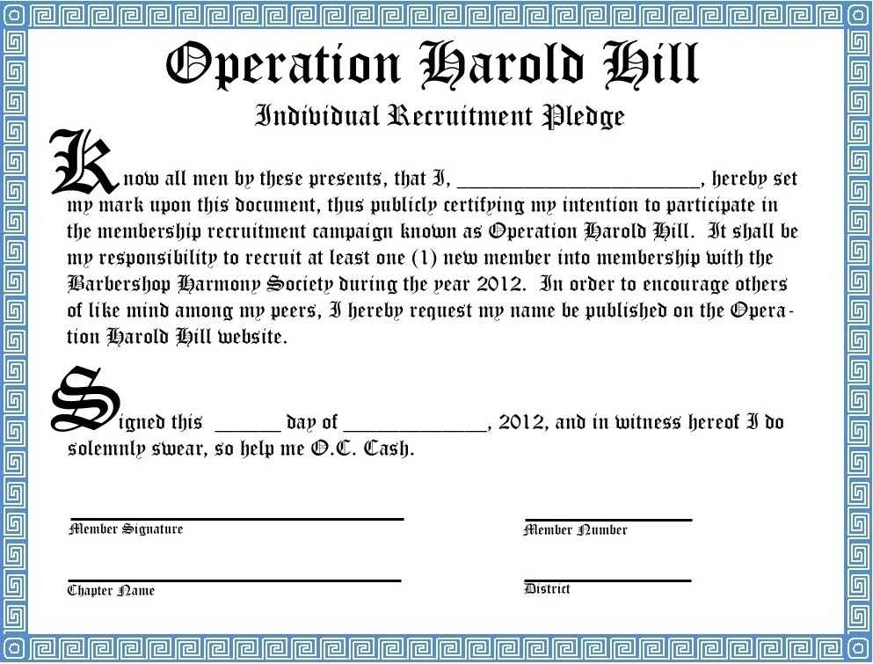
Please sign this if you really mean it. Go to http://www.operationharoldhill.com/ and if you need assistance, just ask Harvey.

