
Barbershop Harmony Society, 110 7th Avenue N., Nashville, TN 37203-3704 www.barbershop.org
Land-O-Lakes District - LOL home page: www.loldistrict.org
1,000 Lakes Division –Probe Member
Our fifty-eighth year – Issue 1, January, 2015
Upcoming performances –Dan Valentine, coordinator

Mon. January 7, 2015, 7:30 PM - Chorus Practice, Larry Fisk- Lunch
A longer lunch list will be upcoming
Fri. -Sat. January 10-11 - Leadership Training Academy in River Falls
Sat. -January 24, 2015 –Youth in Harmony at Amery HS
Youth arrive @ 8:30 AM, concert @ 4:30 PM
Sat. -January 31, 2015 -Lady's Night and Officer Installation Night at T-Daugs
or, the Crex Convention Center at 429 E. St Rd 70, Grantsburg, WI
Time: 5:30 PM Social time, 6 PM Supper, followed by program
Come to chorus and sign-up or let Larry Fisk know if you can come
Fri. -February 14, 2015 -Singing Valentines
Sat. -March 28, 10,000 Lakes Division Contest in Stillwater
Sat. -April 11, 2015 -Gospel Fest at Alliance Church in St Croix Falls
(Block off 12 noon to 5 pm on your calendars.)
Sat. –June 14, 2015 Wannagan Days, St Croix Falls
Fri. –July 4, 2015, 5:30 PM Forest Lake
Sat. -October 3rd, 2015 -Annual Show in Amery

TO YOU AND YOURS FROM YOUR FRIENDS AT THE INDIANHEAD BARBERSHOP CHORUS AND THE SMOKE SIGNALS MAGAZINE WITH WISHES FOR GOOD HEALTH, STRONG VOICES, AND ABUNDANT JOYS!
A Year Of Promise! Ready To Make 2015 Yours?
Welcome to 2015, as we kick off the month with personal New Year’s resolutions top ‐of‐mind, and when other even more important promises are to be made and hopefully fulfilled. Those other pledges will include oaths of office taken, for example, by our new Congress. Closer to home, they will involve oaths officially administered to our new Board at our January Ladies Night and Officer Installation.
In a search involving Barbershop Harmony Society resources, this writer pulled up a document that contains a number of promises that could be asked to be to be kept by the newly ‐elected officers of our Chapter, AND by our membership, as well. The latter bears noting here. They deserve commitments by every one of us, and your “I dos.”
To the membership, the administrator of the oath pose the following possible questions:
1. Members, do you promise to actively participate in and support the chapter’s programs?
2. Do you promise to volunteer for and actively serve in appointed jobs, committees, etc., to the limit of your time availability?
3. Do you promise to provide constructive input to the Board of Directors and to support the officers in their efforts to conduct the business of the Chapter?
Then, after pledges by officers and members, the installer could say: Members, you have heard the pledges of your officers. Officers, you have heard the pledges of your members. On these pledges, we believe a strong program can be developed and carried out (in 2015), and that these efforts will result in a stronger, better Chapter to the satisfaction and pleasure of the leadership team and the entire membership.
We are confident that you will accept such responsibilities with vigor and a constant earnestness of purpose. In the promising days and weeks ahead, they will contribute to excellence and twelve months achieving our very best.

Youth Harmony Festival on Jan 24th at Amery.
Take a look at the links at the bottom to get an idea of the change going on in the Youth Outreach Movement. I know the die hard Babbershoppers do not like this, but if our chapter is going to grow in the future, we have to expand our thinking on what will be the future. We all love to sing, so begin to think outside the box. Having been to several Midwinter Conventions, I can tell you that you would see first hand what is the future. It does not mean all BBS is gone, but the big chapters are doing a fantastic job of getting the youth to the point of loving to sing all kinds of music. It is a new generation, so let's embrace it, so our great grand kids will be singing BBS and all kinds of music. I will be asking our chapter to do some things down the road, so be prepared.
Happy New Year.
Jon Buss, Youth In Harmony
https://www.youtube.com/watch?v=6y1aOg_UO_A
https://www.youtube.com/watch?v=NSFieUSfxGU
https://www.youtube.com/watch?v=DDfRPtDsedA

Celebratory Singing -- Listen Carefully To Them & Find Members
It happened to me over the holidays and it probably happened to you. The times when voices were joined together for a bit of caroling, singing Auld Lang Syne at the stroke of midnight, and at parties with you in attendance. I’m not talking about your voice. We know how talented you are. I’m talking about theirs. Opportunity knocking loud and clear for potential members. Sure, lots of those voices were absolutely abysmal. But in those groups there were one or two guys with enormous ability. If you paused to listen carefully, you heard them. It was your chance to “pounce.”
Celebrations call for song. And they offer wonderful opportunities to talk up barbershopping. Ever been in a local restaurant when a table erupts in joyous togetherness in singing Happy Birthday? Listen. There may be a potential barbershopper as part of the group.
During barbershop quartet gigs, chorus singouts, Valentine presentations, there’s often time to ask those around us to sing with us. Ask THEM to sing Let Me Call You Sweetheart. Encourage others to sing with us. There are new Chapter members out there to be found.
What would you say to the prospective member who said: “I only sing in the shower. I would join a choir, but I don’t think my bathtub can hold that many people.”
Billy Joes says: “I think music in itself is healing. It is an explosive expression of humanity. It’s something we are all touched by. No matter what culture we’re from, everyone loves music.”

Dan Valentine honored in another setting!
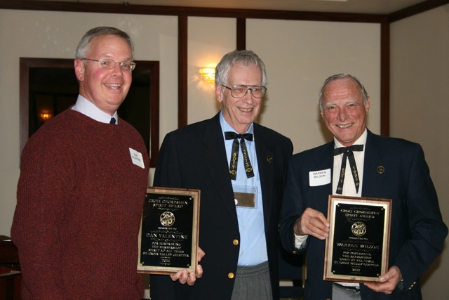

Dan Valentine and Warren Wilson (tied) were awarded the Croix Chordsmen Spirit Award for “portraying the barbershop spirit at all times”. The awards were presented at the Croix Chordsmen officer installation dinner on December 9th 2014 at the Lowell Inn, Stillwater MN. The presenter was John Roeber.

This is a pitch pipe!
Dr. Jim Richards, Singing Judge Gleaned from a 2007 column in Chord-inator Minneapolis, MN Chapter
It has 13 holes. Two of them, labeled “F”, are the same note with one transposed up an octave. The pitch of each note is determined primarily by its frequency in Hz. This useful device lets us start a song in any of 12 major keys or 12 minor keys. Getting started off is its only purpose. The distance between any two notes on the pitch pipe defines a tempered interval. Intervals are not defined by the number of Hz separating the notes. Rather, they are defined by the ratios of their frequencies. One might ask why the choice was made to divide the octave into 12 steps. Why not 11 or 13 or 19 or 53 or any number for that matter? The answer is that the number 12 is the lowest number of equal‐tempered divisions of the octave that still produces many harmonically useful and reasonably consonant intervals. This choice was made for practical reasons to be able to play melody and harmony on a keyboard instrument.

MUSINGS ON WHAT SOME OF OUR MEMBERS MIGHT BE RESOLVING FOR THE NEW YEAR
KARL WICKLUND ‐ I resolve to get a new “G” string for wife, I mean, my wife's ukulele.
DAN VALENTINE ‐ As Program Coordinator, I will line up a singout for Radio City Music Hall.
PAUL PETERSON ‐ This winter I’ll buy thermal wear so I can be at Ladies Night!
HARLEY SHAFER — Just because I'm old enough to retiree from work, does not mean I will retire from barbershopping!
STEVE OSERO — I resolve to continue my exercise program on my px9,000,000 or whatever the name of that machine is that I use every day.
LOREN NELSON — I still plan to be strong enough to carry a tune despite my 80 some year‐old vocal chords.
KEN METTLER - I will continue to do the Smoke Signals this year since the chorus has promised to double my salary every year from now on.

Great New Year's Resolutions:
1. Pray
2. Go to bed on time.
3. Get up on time so you can start the day unrushed.
4. Say No to projects that won't fit into your time schedule, or that will compromise your mental health.
5. Delegate tasks to capable others.
6. Simplify and unclutter your life.
7. Less is more. (Although one is often not enough, two are often too many.)
8. Allow extra time to do things and to get to places.
9. Pace yourself. Spread out big changes and difficult projects over time; don't lump the hard things all together.
10. Take one day at a time.
11. Separate worries from concerns. If a situation is a concern, find out what God would have you do and let go of the anxiety. If you can't do anything about a situation, forget it.
12. Live within your budget; don't use credit cards for ordinary purchases.
13.. Have backups; an extra car key in your wallet, an extra house key buried in the garden, extra stamps, etc.
14. K.M.S. (Keep Mouth Shut). This single piece of advice can prevent an enormous amount of trouble.
15. Do something for the kid in you every day.
16. Carry a spiritually enlightening book with you to read while waiting in line.
17. Get enough rest.
18. Eat right.
19. Get organized so everything has its place.
20.. Listen to something while driving that can help improve your quality of life..
21. Write down thoughts and inspirations.
22. Every day, find time to be alone.
23. Having problems? Talk to God on the spot. Try to nip small problems in the bud. Don't wait until it's time to go to bed to try and pray.
24. Make friends with Godly people.
25.. Keep a folder of favorite scriptures on hand.
26. Remember that the shortest bridge between despair and hope is often a good 'Thank you Jesus .'
27. Laugh.
28. Laugh some more!
29. Take your work seriously, but not yourself at all.
30. Develop a forgiving attitude (most people are doing the best they can).
31. Be kind to unkind people (they probably need it the most).
32. Sit on your ego.
33. Talk less; listen more.
34. Slow down.
35. Remind yourself that you are not the general manager of the universe.
36. Every night before bed, think of one thing you're grateful for that you've never been grateful for before. GOD HAS A WAY OF TURNING THINGS AROUND FOR YOU.coat, jacket,
A SONG ALSO IN HIS HEART:
The Indianhead Barbershop Chorus salutes the achievements of Martin Luther King Jr. on the occasion of MLK Day, January 19, 2015, and notes that, at 10 years of age, his early vocal expressions included singing in his father’s church choir. Members of that choir, incidentally, (the young King included) sang at the premiere of the classic film Gone With the Wind in Atlanta. Pictured is a young MLK.
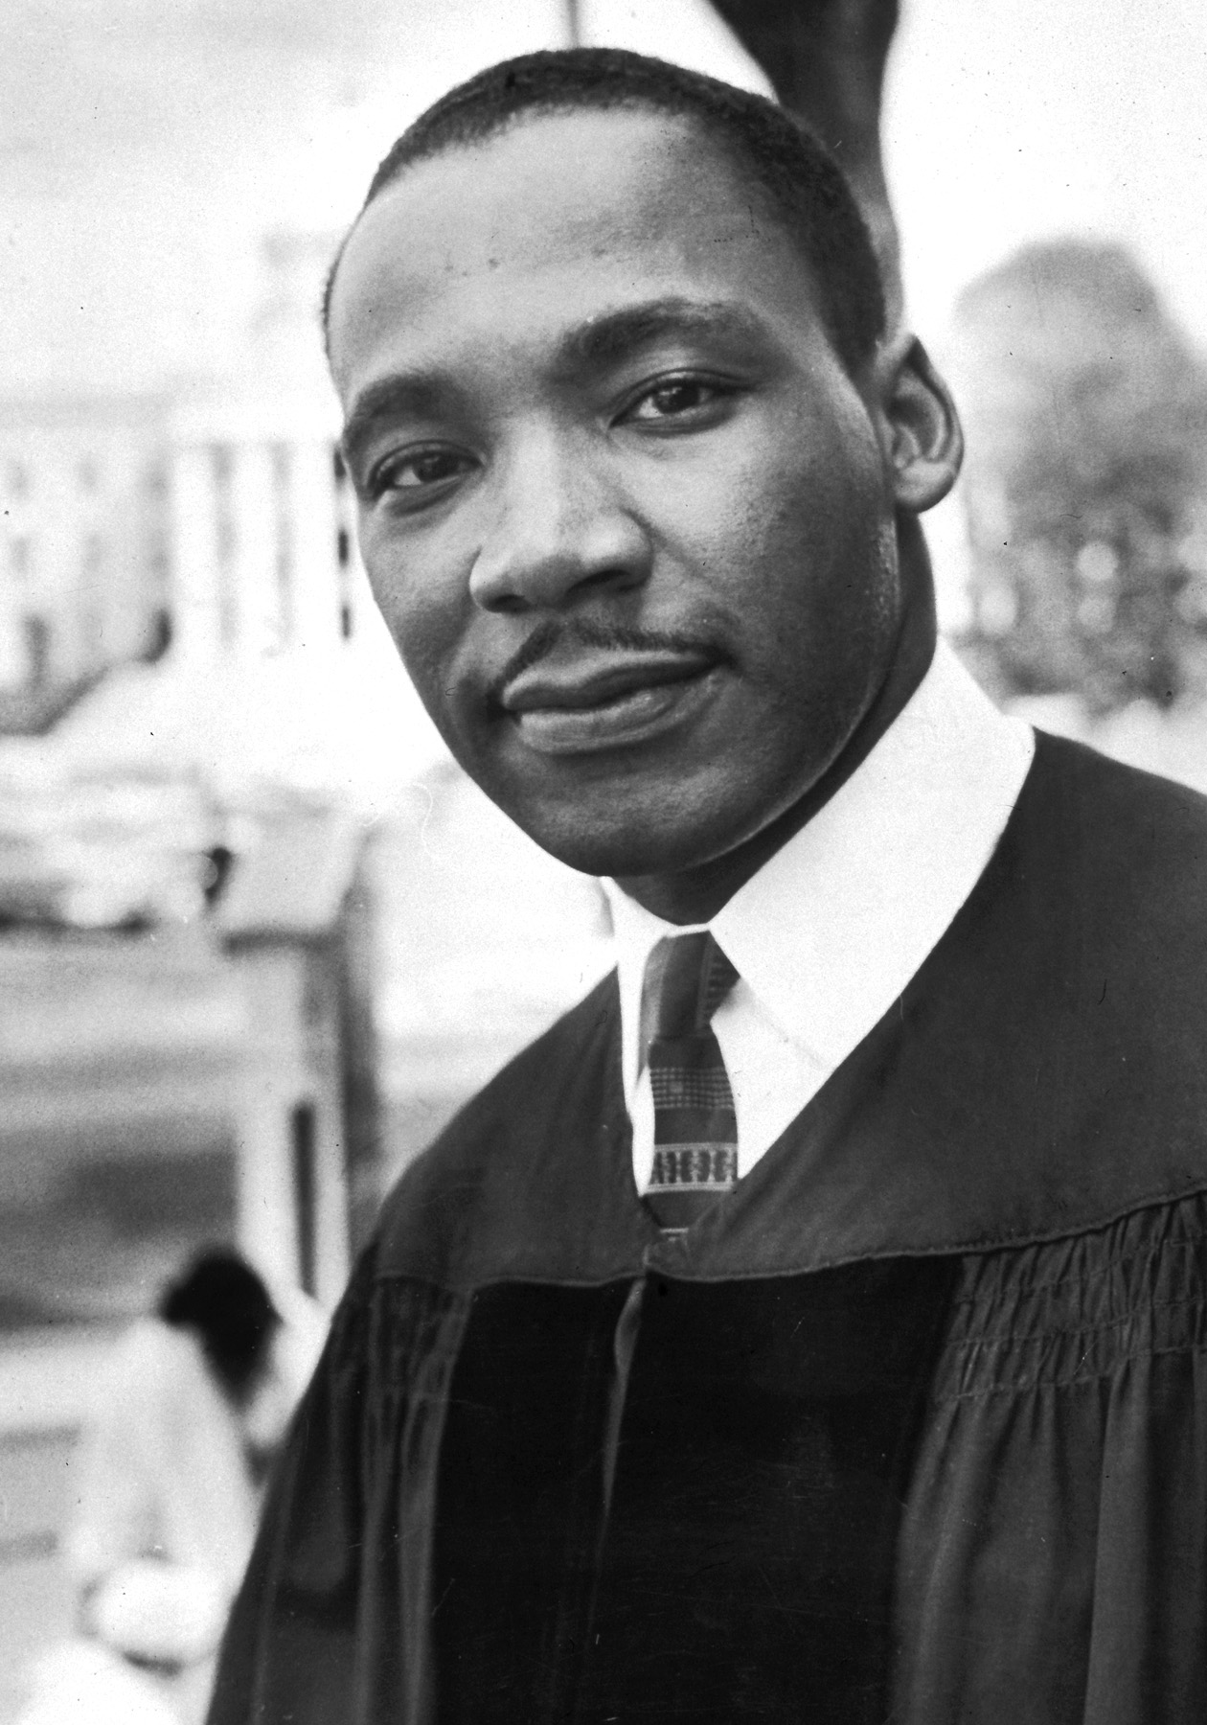

Funology

- My grandmother is over eighty and still doesn't need glasses. Drinks right out of the milk bottle.
- My husband wanted one of those big-screen TVs for his birthday. So I just moved his chair closer to the one we have already.
- I haven't spoken to my wife in years. I didn't want to interrupt her.
- The most remarkable thing about my mother is that for 30 years she served us nothing but leftovers. The original meal has never been found.
- If you love something, set it free- unless it's chocolate. Never release chocolate.
- My therapist told me the way to achieve true inner peace is to finish what I start. So far I've finished two bags of M&Ms and a chocolate cake. I feel better already.
- Insanity doesn't run in my family. It gallops.
ASK ME About Singing

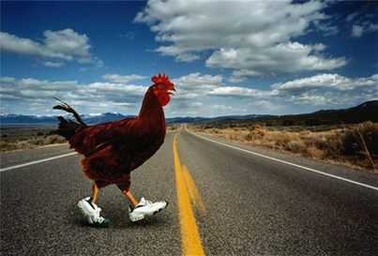

Why Did The Chicken Cross The Road? Shawn E. OSteen
SARAH PALIN: The chicken crossed the road because, gosh-darn it, he's a maverick!
BARACK OBAMA: Let me be perfectly clear, if the chickens like their eggs they can keep their eggs. No chicken will be required to cross the road to surrender her eggs. Period.
JOHN McCAIN: My friends, the chicken crossed the road because he recognized the need to engage in cooperation and dialogue with all the chickens on the other side of the road.
HILLARY CLINTON: What difference at this point does it make why the chicken crossed the road?
GEORGE W. BUSH: We don't really care why the chicken crossed the road. We just want to know if the chicken is on our side of the road or not. The chicken is either with us or against us. There is no middle ground here.
DICK CHENEY: Where's my gun?
BILL CLINTON: I did not cross the road with that chicken.
AL GORE: I invented the chicken.
JOHN KERRY: Although I voted to let the chicken cross the road, I am now against it! It was the wrong road to cross, and I was misled about the chicken's intentions. I am not for it now, and will remain against it.
AL SHARPTON: Why are all the chickens white?
DR. PHIL: The problem we have here is that this chicken won't realize that he must first deal with the problem on this side of the road before it goes after the problem on the other side of the road. What we need to do is help him realize how stupid he is acting by not taking on his current problems before adding any new problems.
OPRAH: Well, I understand that the chicken is having problems, which is why he wants to cross the road so badly. So instead of having the chicken learn from his mistakes and take falls, which is a part of life, I'm going to give this chicken a NEW CAR so that he can just drive across the road and not live his life like the rest of the chickens.
ANDERSON COOPER: We have reason to believe there is a chicken, but we have not yet been allowed to have access to the other side of the road.
NANCY GRACE: That chicken crossed the road because he's guilty! You can see it in his eyes and the way he walks.
PAT BUCHANAN: To steal the job of a decent, hardworking American.
MARTHA STEWART: No one called me to warn me which way the chicken was going. I had a standing order at the Farmer's Market to sell my eggs when the price dropped to a certain level. No little bird gave me any insider information.
DR SEUSS: Did the chicken cross the road? Did he cross it with a toad? Yes, the chicken crossed the road, but why it crossed I've not been told.
ERNEST HEMINGWAY: To die in the rain, alone.
GRANDPA: In my day we didn't ask why the chicken crossed the road. Somebody told us the chicken crossed the road, and that was good enough for us.
BARBARA WALTERS: Isn't that interesting? In a few moments, we will be listening to the chicken tell, for the first time, the heartwarming story of how it experienced a serious case of molting, and went on to accomplish its lifelong dream of crossing the road.
ARISTOTLE: It is the nature of chickens to cross the road.
BILL GATES: I have just released eChicken2014, which will not only cross roads, but will lay eggs, file your important documents and balance your checkbook. Internet Explorer is an integral part of eChicken2014. This new platform is much more stable and will never reboot.
ALBERT EINSTEIN: Did the chicken really cross the road, or did the road move beneath the chicken?
COLONEL SANDERS: Did I miss one?

