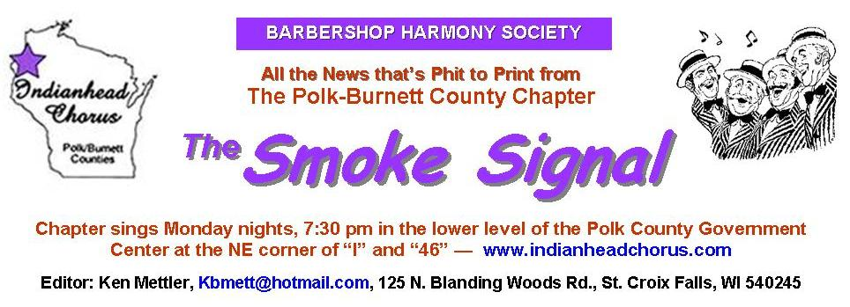
Barbershop Harmony Society, 110 7th Avenue N., Nashville, TN 37203-3704 www.barbershop.org
Land-O-Lakes District - LOL home page: www.loldistrict.org
1,000 Lakes Division –Probe Member
Our fifty-seventh year – Issue 1 - January, 2014

Cots is January 3-4 at River Falls
January 24 is Ladies Night and awards night?

2014 CHORUS REP LIST
1. When the Red Red Robin. Key of E Minor
2. Let’s Get Away From It All. Key of F
3. If You Knew Suzie. Key of C
4. I Don’t Know Why. key of B flat
5. Beautiful Savior. Key of E Flat
6. Little Light Medley. Key of A
7. Sweet Mae. Key of B flat
8. Heart. key of F
9. That Railroad Rag. Key of E flat
10. Hello My Baby Key of F
11. Don’t Blame Me. Key of D
12. I’d Give A Million Tomorrows Key of G
13. Don’t Put A Tax Key of C
14. America Key of C
15. Little Girl

Crank up the New Year!

It’s 2014 and we start a new year of performances, practices and competition. It’s an important year for our chorus. As barbershop singers we must try and preserve the singing style we love. That means we have to make a conscience effort to recruit more singers to our ranks. We should be proud of the accomplishments of the Polk-Burnett Indianhead Chorus over its existence. The quality entertainment we have provided our audiences does not come without your time, effort and diligence. Everyone should be proud of their accomplishments while singing Barbershop Harmony with our chorus. Let’s help make us a better chorus by recruiting singers. It takes just a little more effort but the rewards will help insure people in NW Wisconsin will be enjoying our singing for a long time to come. So let’s make 2014 a great year with lots of fun and more chorus members.
Thank You,
Archie Lessard, President

The Indianhead Chorus mailing list…

I've had some questions over the last few weeks about our emailing list. If the list is working fine for you, then you can ignore this article.

Please remember, the old groupanizer list is no longer functional. The list address is members@indianheadchorus.org. This switch happened several months ago. If you are not getting my weekly updates on the rehearsal plan or Dan’s weekly updates on VLQ rehearsals, you are not getting the group emails. If you’re not on the list, but would like to be, follow the steps at the end of this article. Let me know if you need help.

According to my information, the following people are currently on that list, and should be receiving regular emails. If your address is listed correctly below, and you’re still not getting the emails you want, please let me know! (I haven’t included your entire address in this list, just to preserve some privacy; back issues of Smoke Signals are posted online.)

Buss, Jon – al***@gmail.com
Durand, Larry – la***@yahoo.com
Fisk, Larry – la***@centurytel.net
Gjerde, Clint – cl***@amertel.net
Lessard, Archie – ar***@mastec.com
Manwiller, Cliff – cm***@amerytel.net
Mettler, Ken – kb***@hotmail.com
Nelson, Mark – md***@yahoo.com
Pederson, Paul – pe***@grantsburgtelecom.net
Pertersen, Carl – ka***@chibardun.net
Pickard, Neil – pi***@amerysd.k12.wi.us
Roeber, John – jk***@lakeland.ws
Salmela, Alan – al***@frontiernet.net
Sandahl, Harvey – sa***@yahoo.com
Shobe, Bryan – sh***@ centurytel.net
Stone, Duane – du***@gmail.com
Swenson, Steve –sk***@centurytel.net
Valentine, Dan – da***@gmail.com
Wallace, Dave – ar***@gmail.com
Williamson, Chuck – wi***@hotmail.com

I also have the following addresses, but I’m not sure who owns them. If this is you, there’s no need to do anything, unless you’re not receiving the emails you want to receive.
carcrazybill@****.***
frederic @****.***
gary@ ****.***
eljay@****.***
rcjvalleyview****.***

If you want to get on the email list, follow these directions:

- Go to www.indianheadchorus.org. On the left side of the screen click “members.” | 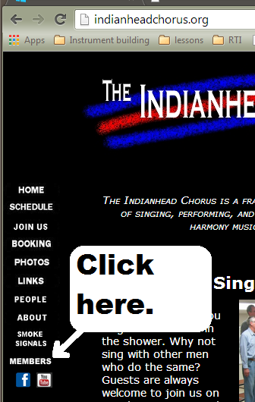
- Then, click the blue member mail link at the top of the page. The link reads: http://membermail.indianheadchorus.org/listinfo.cgi/members-indianheadchorus.org | 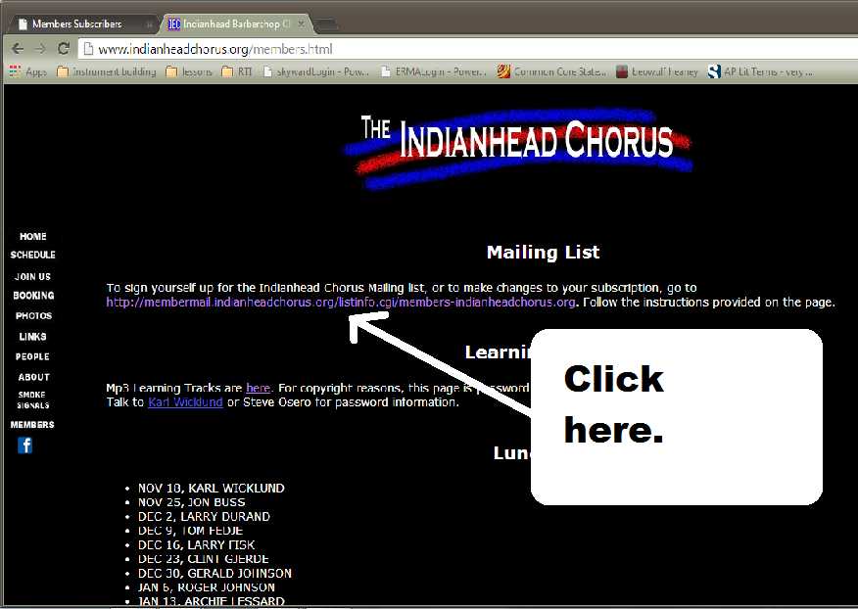
- Once you’re on the beige page, fill out the appropriate information. It will ask for :  -your email address  -your name (if you care to include it.  -a password  It also asks if you want all messages sent individually, or bundled into one ‘digested’ message at the end of the day. Only rarely is there more than one message coming on a single day, so there isn’t much practical difference between these options. | 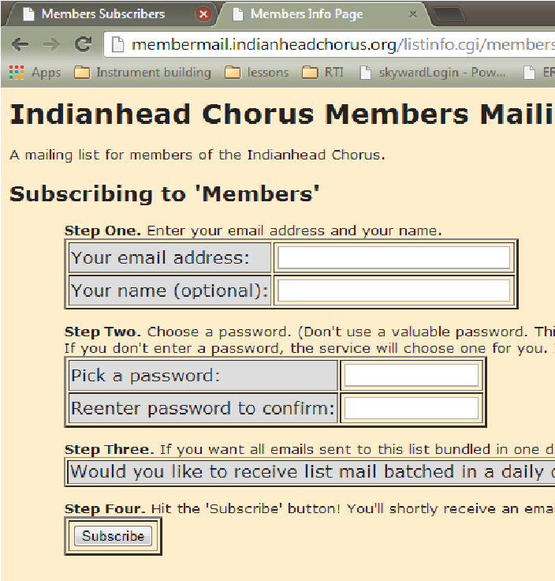
- Hit the “Subscribe” button, and you’ll shortly receive an email from the site. If you do not follow the simple confirmation steps in this email, you will not be added to the list.
-if this email does not arrive after a day, check your spam folder, just in case.
That should do it. Again, if you’ve got any questions, just let me know!

Karl Wicklund, Assistant Director

2014 Leadership Academy Experience

Thank you to the chorus for paying for my attendance to the Leadership Academy. I wish the whole chorus could go! There were barbershoppers with over 50 years of experience and others with less than 1 year of experience. Barbershoppers are such a friendly group. Chapters from Green Bay, to Polk County, and even Winnipeg Canada were there (it’s only a little over an hour from Luck to River Falls). It is fun to renew the bonds of brotherhood in song each year.
The most intense study I attended was WaveBox Singing with Paul Ellinger. He is a member of Chordology Quartet. They performed on our show about 5-6 years ago. He presented this concept to us at our dress rehearsal at that time. Saturday, there were about 150 men in the room and were ringing so many chords with so little effort that it was amazing. It was just amazing to sing with a group that size. The concept of “Regal Stance” makes it easy to be in the near perfect singing position and mental readiness. The “Wall of Sound” concept is something Steve and Karl tell us about in different words. It makes SUCH a difference in the sound. We really need to just wrap our head around these concepts. We will become a better chorus.
On Saturday, I attended the Barbershop Smorgasbord session with Scott Kvigne. Scott sings with Great Northern Union and is the director of the Sweet Adeline City of Lakes Chorus. He is a wealth of knowledge and experience. It was a four hour session that flew by. It was that interesting and interactive. Scott used voice placement and made a VLQ out of the 13 present. It was strange that there were more tenors than leads in the group. The chorus director’s class joined us at 10 am and used our group as a practice chorus. It is amazing what a director can do to get a group to sing (or not). Steve and Karl are pretty darn good compared to what I experienced Saturday.
I attended Designing a Chorus/Quartet Repertoire with Adam Scott. Adam is from Nashville and is the music educator/ music editor of the Society. He clears all arrangements and publishes them for the Society. Karl and I sat with him for lunch Saturday. He travels the country and told us that Lake O Lakes and the Johnny Appleseed districts are his favorite districts. We asked lots of questions and he gave us updates on the future features of the music publication system and how members can access it. In his 90 min session on repertoire, he presented a check list of sort in choosing music for chorus and quartets. Others shared their experiences in music selection.
The most challenging session for me was Barbershop Ear Training with Jim Wirtz. This is something I really need to work on. Steve and Karl are always telling us it’s a third or fourth interval. If I spend time with the tools I was given and practice with them I should improve my sight reading of music. Steve and Karl are really practiced at that. Minor 2nd, Major 3^{rd,} etc. There are in depth resources on the Society website for this training and more. We get a lot for what we pay in dues!
This event recharged my passion for barbershop. What I took away from this year’s session is that our audience wants us to do our best. If we strive to make basic singing techniques a habit- breath support, forward sound, lift the cheeks, sing phrases to the end, energize phrases, smile, move, sell the song and just make music we will be able to shift our focus to singing the song with passion and our audience will love it.
A non-barbershop audience loves us when we sing. They think we are pretty good even though we may have thought it was a train wreck. A barbershop audience wants us to succeed, understands when we mess up and forgives us because they have been there too. We do this for fun and we want to share our unique sound with our community. So this year I resolve to be a better singer, support my chorus by learning my music quickly, helping others be their best and sing for the joy of singing. Remember…SMILE, it’s great to be a barbershopper!

Dan Valentine, Performance Coordinator
Lunch List (a year of D.S. al fine dining)
Definition: D.S. al fine, or dal segno al fine, literally means “[play] from the sign to the end.” D.S. al fine is an indication to start back at the segno, and continue playing until you reach the final barline, or a double-barline marked with the word fine.

• JAN 6, ROGER JOHNSON
• JAN 13, ARCHIE LESSARD
• JAN 20, CLIFF MANWILLER
• JAN 27, KEN METTLER
• FEB 3, DUANE MORRIS
• FEB 10, MARK NELSON
• FEB 17, STEVE OSERO
• FEB 24, PAUL PEDERSON
• MAR 3, CARL PETERSON
• MAR 10, NEIL PICKARD
• MAR 17, ALAN SALMELA
• MAR 24, HARLEY SCHAEFER
• MAR 31, BRYAN SHOBE
• APRIL 7, BILL STEVENSON
• APRIL 14, DUANE STONE
• APRIL 21, STEVE SWENSON
• APRIL 28, DAN VALENTINE
• MAY 5, DAVE WALLACE
• MAY 12, MARK WESLANDER
• MAY 19, KARL WICKLUND
• MAY 26, CHUCK WILLIAMSON
• JUNE 2, ED BONESKY
• JUNE 9, JON BUSS
• JUNE 16, LARRY DURAND
• JUNE 23, TOM FEDJE
• JUNE 30, LARRY FISK
• JULY 7, CLINT GJERDE
• JULY 14, GERALD JOHNSON
• JULY 21, ROGER JOHNSON
• JULY 28, ARCHIE LESSARD
• AUG 4, CLIFF MANWILLER
• AUG 11, KEN METTLER
• AUG 18, DUANE MORRIS
• AUG 25, LOREN NELSON
• SEPT 1, MARK NELSON
• SEPT 8, STEVE OSERO
• SEPT 15, PAUL PEDERSON
• SEPT 22, CARL PETERSON
• SEPT 29, NEIL PICKARD
• OCT 6, ALAN SALMELA
• OCT 13, HARLEY SCHAEFER
• OCT 20, BRYAN SHOBE
• OCT 27, BILL STEVENSON
• NOV 3, DUANE STONE
• NOV 10, STEVE SWENSON
• NOV 17, DAN VALENTINE
• NOV 24, MARK WESLANDER
• DEC 1, ED BONESKY
• DEC 8, CHUCK WILLIAMSON
• DEC 15, KARL WICKLUND
• DEC 22, JON BUSS
• DEC 29, LARRY DURAND

Our 2014 LYN Campaign Kick-Off

If you remember, last year we asked our choruses to get involved in the ARK project; that is: Acts of Random Kindness. We encouraged chapters to contact local hospitals and nursing homes and coordinate days to sing for those under their care. It often involved bringing shows to the whole institution or taking our music to patients in their rooms.

This world could use a little more kindness and love. Judson College in Alabama is a Baptist college for women. A few years ago, the chaplain from Judson told about the time he was leading in prayer in the all-female chapel service. He prayed, “Lord, give us kind hearts, Lord, give us loving hearts. Lord, give us sweet hearts!” And all the women said, “Ah-men!”
Yes, we do need kind hearts, and there’s an underground movement gaining momentum throughout America to bring back acts of love and kindness to others. This year I would like to expand what we were doing into a program called The LYN campaign. LYN stands for “Love Your Neighbor.” I am proposing that each chapter launch an LYN campaign for 2014. The goal is for you to go out into the community and as quartets and choruses perform and do acts of kindness for strangers. The LYN strategy is simple: Every quartet and chapter performing and doing intentional acts of kindness to show the love and kindness to others.
Last year I encouraged you to do this in nursing homes and hospitals. But, why stop there. This year, show your appreciation to teachers, firefighters, policemen, EMT workers, anyone who needs attention; anyone you can find.
1. KINDNESS IS OUR RESPONSE OF GENUINE GRATITUDE.
Why should we show kindness to others? When you show kindness to a stranger, they are surprised. Why? Because that’s not normal behavior. In everyday life it is every man for himself. It’s a dog-eat-dog world. But we can live by a higher standard. We can show kindness and compassion to others.
2. DIRECT YOUR KINDNESS TOWARD STRANGERS WHO CANNOT REPAY YOU.
As you go out and perform your acts of kindness; it’s okay to do them to family, friends, but really focus your kindness on total strangers. They can’t pay you back. And like that movie, “Pay it Forward”; maybe they’ll pass your kindness on to someone else who will pass it on to someone else. This conspiracy of kindness thing could really catch on!
3. PERFORM YOUR KINDNESS TO BUILD CHORUS IDENTITY!
There’s a movement in America called Random Acts of Kindness. That’s wonderful, we can never have too much kindness, but there needs to be purpose behind your acts of kindness. You need to make a statement when you perform and do your acts of kindness.
I heard a funny story about a woman in Louisville, Kentucky, who was standing at a bus stop. She had just cashed her tax refund check, so she was carrying more money than usual. She glanced around and noticed a shabbily dressed man standing nearby. And as she watched, a man walk up to him, handed him some money, and whispered something in his ear. She was so touched by the act of kindness she decided to do the same. In a burst of generosity, she reached into her purse, took out $10, handed it to the man, and whispered to him, “Never despair, never despair.”
The next day when she came to the bus stop, the same man was there again. But this time he walked up to her and handed her $100. Dumbfounded, she asked, “What’s this?” He said, “You won, lady. Never Despair paid 10 to 1 at Churchill Downs yesterday!” (You see, there was a horse, named Never Despair...).
Don’t let your motives be confused. The whole point of LYN year is to promote your chorus. Prepare LYN cards and tell others about your chorus. Go to places that may not have heard of your existence.
4. KINDNESS IS PLANTING SEEDS OF FRIENDSHIP.
When you share your music, follow it up with doing something helpful. Here are a few LYN activities you can do, or you can come up with your own.
(1) One of the easiest things to do is to go to a parking lot and wash windshields. Sing as you wash.
(2) Get a roll of quarters and go to a Laundromat. Ask to pay for someone’s wash load. Then gather the quartet around and sing.
3) Take a shoe shine kit and go to the doctor’s waiting rooms at the Clinic. Be sure to give them a LYN card when you sing for them.
(4) Grab your ice chest and fill it with little bottles of water. Station yourself near where people park for the jogging trails. Give them a LYN card.
(5) Go to the store and buy several packs of light bulbs. Remember to leave a LYN card–and remember to smile as you sing!
(6) Here’s a neat one. When your quartet is in line at a fast-food place, offer to pay the bill for the person behind you. Give the cashier a LYN card and tell them to give it to the person when they finish their order, tell them it is paid for. You might not want to do this if the family behind you has 8 children and they have big appetites!
These are just a few ideas; now you go out and come up with your own ideas.
So, chorus members, let’s get off our seats and into the streets and let’s give ‘em KINDNESS! That’s a great way to market the magic of Barbershop Harmony!
I have sent this article off to be published in the next Pitch Piper, but, wanted you our chorus to get a jump on the news. -Ken

