
Barbershop Harmony Society, 110 7th Avenue N., Nashville, TN 37203-3704 www.barbershop.org
Land-O-Lakes District - LOL home page: www.loldistrict.org
1,000 Lakes Division –Probe Member
http://indianhead.groupanizer.com
January, 2012; Vol. 55, Issue 1

Closer than you think:
(Dates on the calendar are like objects in the rear-view-mirror)
*Jan. 2nd- Earl Hillestad’s Funeral -11 AM at the Methodist Church in New Richmond (practice 10 AM). (See pg. 10)
*No practice on Jan. 2nd. The courthouse is closed.
*We will be practicing on Tuesday, January 3rd, at 7:30 at the Courthouse.
*Leadership Academy at River Falls, January 6th and 7th.
*Youth in Harmony at St Croix Falls Gymnatorium – Sat., January 14th.
*Ladies’ Night and officer installation at Village Pizzeria in Dresser on Saturday, January 28th.
*Singing Valentines –tell everyone about Feb. 14th SVs!
*Barbershoppers sing at the Metrodome: Plan ahead to sing the National Anthem for the Minnesota Twins. The date is Sunday, August 12. The Twins will be playing the Tampa Bay Rays. Gather about 11 am as the game start is noon.
*International Convention July 1-8, 2012 in Portland, OR

Barbershop Harmony Society Vision Statement

The Society, in alliance with other a cappella organizations worldwide, is committed to enriching lives in every generation and community through the lifelong benefits of a cappella harmony singing.

Step Forward Now!

This is the theme being used in the Barbershop Harmony Society to recruit new members. So what does stepping forward look like for each of us?

Stepping forward means each person is supposed to talk to other singers, friends, relatives and ask them to join us…you are to step forward and do the asking.

This may not be as intimidating as you might think. It is all about ‘sharing your story.’ Tell others why you love to do Barbershop singing; what excites you; what makes you want to keep coming back?

Each of us has a different story; perhaps from our childhood love of music, a special person who taught us, a time when music filled a need, satisfied a hunger, or just brings your heart joy. For me, I discovered at a young age in Sunday School that I liked to sing the right notes and it seemed liked I was really contributing to the song. Now, I feel a need to sing, to share songs with others and bring enjoyment to listeners and myself.

Each of us has a story and needs to share that story with others so more men will use their voices to lift music up with joy and satisfaction. Share your story with all people so the stories spread, and others hear what fun it is to be in Barbershop. Your enthusiasm will show in your discussion with people and that will help grow our membership….stepping forward.

Share your singing story with others, let us know what happened and watch our community of singers grow.

What is your idea to attract more men to our Chapter meetings? Please contact me at sandahlh@yahoo.com or (651) 226-9687 with any membership questions or ideas.

Thanks,
Harvey Sandahl, Membership VP

Here’s your “Thought for the Day”:
An Irish father was seeing his son off on a steamship where the lad was going to a new land with the intention of seeking his fortune in a new way of life. "Now, Michael, me boy," said the father as they parted, "remember the three bones, and ye’ll always get along all right."
A stranger standing nearby overheard the remark, and when the ship was underway, he asked the old gentleman what the three bones he referred to in his parting advice to his son.
"Sure, now," responded the old Irishman, "and wouldn’t it be the wishbone and the jawbone and the backbone? It’s the wishbone that keeps ye goin' after things, and it’s the jawbone that helps ye find out how to go after them if ye're not too proud to ask a question when there’s something ye don’t know, and it’s the backbone that keeps ye at it until you get there." – Source Unknown

Happy New Year, 2012
New Year resolutions are always wishes for what we hope the New Year will bring. It is a positive thinking exercise that many people avoid because it is very hard to make changes and to break old habits. So many of us don’t even bother anymore and just go along as before hoping for the best or at a minimum- it won’t get any worse. Sometimes things happen, often beyond our control that forces us to make changes (like winning the POWER BALL lottery! – no, I didn’t).
Your Indianhead Chorus is making changes or at least studying what changes we can make to
- Improve our singing
- Make learning new songs easier
- Shorten the song-learning process so we can concentrate on the “polish”
- Exploring a change of venue for our annual show
- Visit other choruses
- Compete with confidence at the Division and District levels.
- Increase the number of public performances each year
- New uniforms
- Attending Society educational opportunities
If you need help with music, or have any thoughts or concerns about anything regarding the chorus let me or any of the board members know. It promises to be an exciting year as long as we are all willing to make a stronger effort to learn our music, attend weekly practice and have a positive attitude with whatever changes we make. Remember, singing well and performing well is our hobby/passion. We have a sense of pride belonging to the Indianhead Chorus. Let’s have that pride shine through in everything we do.
VLQ Contest in Mankato 2012?
I have once again contacted the powers that be at the Land of Lakes District asking for a VLQ contest at Mankato this spring. In short, the answer was “we may not have time” because it is a combined contest with the Southwest Division- more groups to judge and meet with. There is a ray of hope; they are going to discuss it at the January Leadership Academy in River Falls.
The Indianhead Chorus VLQ will be performing at the United Pioneer Home and the Frederic Home on Sunday, January 22nd. The times are: Luck 2:15 pm performance start then onto Frederic. Wear the winter uniform, burgundy shirts, tan dockers, black shoes, and black belt.
Thanks,
Dan Valentine

Here Comes 2012!

Hard as it is to believe, we are already entering a new year. Along with some possible resolutions, it provides an opportunity to think about what we will do differently in 2012.
One thing we'll have to do differently in the New Year is recruit members to the Indianhead Barbershop Chorus. Despite it being one of our primary goals for the last two years, we had a net loss in 2011 of two members. We need gains, not losses.

The new board will be having a retreat on January 17th, and I'll make sure that our primary goal centers on membership. Harvey is again our Membership Vice President, but all of us have to recruit. His job is to help us coordinate our efforts, and we're going to try to give him the tools to do that.

I wish you and your families a very happy and successful new year!
Mark Nelson, President

Vocal Education Attitude + Power = Performance -By René Torres
During pilot training for an instrument rating, the qualifications for “flying blind” require the student to learn many acronyms and mnemonics related to flying an aircraft without being able to see out the window. One of the most stressed expressions is: Attitude plus Power equals Performance. This means that, if you place the aircraft in a given attitude and use the same power setting every time, with practice you will know what the aircraft will do about it. In other words, for a given attitude and a given power setting, the aircraft will do one–and only one–thing. If you know what that is and practice it, then each time you have that given attitude and power setting, you will have the same performance.
As the expression kept going through my mind, it occurred to me that it is more far-reaching than just a memory jogger for flying instruments. Let’s look at what it could mean to the chorus as well as the chorus member.
Attitude
The importance of proper mental attitude for a perfect performance has been mentioned in previous articles. Every chorus member needs to have the proper mental attitude to be able to sing at his best. This requires a combination of proper warm-up (both physical and mental) and stamina, a healthy disposition, and an overall readiness to sing. When all these items are combined consciously and applied religiously, then the right “mindset” is developed and good things can and will happen. Miss any one of them, and you will be less of an asset to the chorus.
So, do YOU have the right attitude? It’s actually very simple. Here are a few points to remember. Arrive at rehearsals on time; be mentally prepared and vocally warmed up; don’t talk on the risers; pay attention to the director; and, above all, put your heart and soul into each and every song every time you sing.
Whether at rehearsal or during a performance, each member of the chorus must be singularly focused every time he is on the risers. When ...POWER... a few members are “off,” the entire chorus is off! The only way to achieve a proper overall chorus attitude is for each member to have the proper individual attitude.
...Plus...
If all it took was a proper attitude, then any chorus could resolve to have the right attitude and become international champion! Unfortunately, it doesn’t work that way. You need attitude plus. Here is where confidence in yourself pays off handsomely. If you have the right training, maintain the proper personal regimen and listen to your director and section leaders, then you are a long way toward having that attitude plus.
There is always a spark–something special–that distinguishes a championship chorus from average chord singers. It’s that “plus” ingredient inside that needs to be let out and allowed to combine with the proper chorus attitude. That’s what makes you and, consequently, the chorus so special.

When I was studying voice at New York University, world famous opera singer Anna Moffo told me something I have never forgotten. She said: “A good singer can sing great when he wants to, but a great singer can sing great even when he doesn’t want to.” Think about it! Is there a better definition of the “plus” attitude?
...Power...
In an airplane, power comes from the engine acting through the propeller or jet exhaust. In a singer, power comes from the diaphragm and lungs acting through the vocal chords. An aircraft engine provides a certain amount of power given a certain setting. A trained singer provides a certain sound given a certain physical “setting.” There’s no difference. With proper training, good diet and stamina and knowledge of what you are doing, you have the power! If you have a smooth running engine that is trained for singing, properly lubricated and controlled, you have everything you need to react to the attitude you have set in your mind. All the ingredients are there, and all you have to do is practice the combination until you know what the result will be.
...Equals...
The American Heritage Dictionary defines equal as “having the requisite qualities, such as strength or ability, for a task or situation.” Following this definition, we easily see that, if there is the right attitude present, the “plus” factor discussed above and the power, then we have the requisite qualities, strengths and abilities to be “equal” to the task at hand. We become an integrated part of the whole and are ready to give 100%.
Another dictionary definition of equal is “showing or having no variance in proportion, structure, or appearance.” This brings up the issue of repeatability. The purpose of the rehearsal is to make a song come out the same way every time it is sung. It also assures that every singer has practiced the piece and is “on the same page.” Rehearsals are supposed to make things repeatable, identically reproducible, over and over again.
Performance
The performance is the bottom line, the reason for a performer’s existence. It’s where all you have done to that point shows up, rightly or wrongly. It’s where points are scored, standing ovations are earned, and true championship caliber is displayed. Need I go on? Never forget: Attitude + Power = Performance

HUMOR FOR LEXOPHILES (LOVERS OF WORDS)

I wondered why the baseball was getting bigger, and then it hit me.
Police were called to a daycare where a three-year-old was resisting a rest.
Did you hear about the guy whose entire left side was cut off? Well!!! He's all right now.
The roundest knight at King Arthur's round table was Sir Cumference.
The butcher backed up into the meat grinder and got a little behind in his work.
To write with a broken pencil is pointless.
When fish are in schools they sometimes take debate.
The short fortune teller who escaped from prison was a small medium at large.
A thief who stole a calendar got twelve months.
A thief fell into wet cement. He became a hardened criminal.
Thieves who steal corn from a garden could be charged with stalking.
We'll never run out of math teachers because they always multiply.
When the smog lifts in Los Angeles, U.C.L.A.
The geology professor discovered that her theory of earthquakes was on shaky ground.
The dead batteries were given out free of charge.
If you take a laptop computer for a run you could jog your memory.
A dentist and a manicurist fought tooth and nail.
A bicycle can't stand alone; it is two tired.
A will is a dead giveaway.
Time flies like an arrow; fruit flies like a banana.
A backward poet writes inverse.
In a democracy it's your vote that counts; in feudalism, it's your Count that votes.
A chicken crossing the road: poultry in motion.
If you don't pay your exorcist you can get repossessed.
With her marriage she got a new name and a dress.
Show me a piano falling down a mine shaft and I'll show you A-flat miner.
When a clock is hungry it goes back four seconds.
The guy who fell onto an upholstery machine is now fully recovered.
A grenade fell onto a kitchen floor in France , resulted in Linoleum Blownapart.
You are stuck with your debt if you can't budge it.
Local Area Network in Australia : The LAN down under.
He broke into song because he couldn't find the key.
A calendar's days are numbered.
A lot of money is tainted: 'Taint yours, and 'taint mine.
A boiled egg is hard to beat.
He had a photographic memory which was never developed.
A plateau is a high form of flattery.
Those who get too big for their britches will be exposed in the end.
When you've seen one shopping center you've seen a mall.
If you jump off a Paris bridge, you are in Seine .
When she saw her first strands of gray hair, she thought she'd dye.
Bakers trade bread recipes on a knead to know basis.
Santa's helpers are subordinate clauses. Acupuncture: a jab well done.

Relational Living
It is good to remind ourselves that to live meaningfully we need to be in meaningful relationships, without which life can be very empty and lonely.
If we don't know how to relate in healthy ways, we don't know how to live fully, and we can impair both our mental and physical health as a result. Or another way to put it: to fully live we need to fully love!
We then need close healthy relationships with people. Only then can we realize some of the deepest longings of the human heart. This doesn't mean that we are to be over dependent on others, codependent with them, or independent from them, but interdependent with them.
The reality is that we need people. Barbra Streisand expressed it well in the song: "People who need people are the luckiest people in the world."
Furthermore, the degree of our mental health, emotional maturity, and overall well-being will be reflected in the health or otherwise of our close relationships. Loving one another is not a sentimental suggestion. It's an imperative.
Control your jaw - Avoid a tense jaw:

It’s important to remember as a singer is to have your jaw do as little as possible when you sing. Try to minimize the movement of the jaw itself as you sing. Also, a tense jaw can lead to tension in your throat and upper chest area, can affect resonance, and can cause out-of-tune singing and vocal fatigue. Some singers have a condition known as temporal mandibular joint, commonly referred to as TMJ. The jaw can actually lock itself open if the singer is not careful. This condition can create everything from a minor annoyance to a very painful experience. If you have TMJ, you need to learn just how far you can safely open or drop your jaw before you feel a click or pop. Once you have discovered this position, only open your mouth no further than that point when you sing. Your singing will then be freer from pain and tension.

Here is a web site that will help you to learn more about the history of barbershopping and our Barbershop Harmony Society. We need this refresher every so often! Our Society is made up of men of all ages, from all walks of life, who love to sing.
http://www.barbershop.org/web/groups/public/documents/pages/pub_cb_00167.hcsp#P-7_0

Tradition
I have read how, as a boy in the Midwest, Dale Carnegie used to amuse himself by holding a stick across a gateway that the sheep had to pass through.
After the first few sheep jumped over the stick, Dale would take it away. Oddly enough, all of the remaining sheep would also leap through the gateway over the imaginary barrier. The only reason for their jumping was that those in front of them had jumped.
Sheep are not the only ones with this tendency. Many of us are prone to do what we have seen others do, believe what others believe, and often accept without question what our leaders teach.
Traditions can be a blessing or a bane.
There's much truth in what Gloria Steinem is credited as having said: "The first problem for all of us, men and women, is not to learn, but to unlearn."
There are good traditions that we need to keep, but, certainly not for the sake of tradition.

“Rooneyisms” - RIP MR. ROONEY!
If you will take the time to read these, I promise you'll come away with an enlightened perspective. The subjects covered affect us all on a daily basis:
They're written by Andy Rooney, a man who had the gift of saying so much with so few words. Enjoy!
I've learned.... That the best classroom in the world is at the feet of an elderly person.
I've learned.... That when you're in love, it shows.
I've learned.... That just one person saying to me, 'You've made my day!' makes my day.
I've learned... That having a child fall asleep in your arms is one of the most peaceful feelings in the world.
I've learned.... That being kind is more important than being right.
I've learned.... That you should never say no to a gift from a child.
I've learned.... That I can always pray for someone when I don't have the strength to help him in some other way.
I've learned.... That no matter how serious your life requires you to be, everyone needs a friend to act goofy with.
I've learned.... That sometimes all a person needs is a hand to hold and a heart to understand.
I've learned.... That simple walks with my father around the block on summer nights when I was a child did wonders for me as an adult.
I've learned.... That life is like a roll of toilet paper. The closer it gets to the end, the faster it goes.
I've learned.... That we should be glad God doesn't give us everything we ask for.
I've learned.... That money doesn't buy class.
I've learned.... That it's those small daily happenings that make life so spectacular.
I've learned.... That under everyone's hard shell is someone who wants to be appreciated and loved.
I've learned.... That to ignore the facts does not change the facts.
I've learned.... That when you plan to get even with someone, you are only letting that person continue to hurt you.
I've learned.... That love, not time, heals all wounds.
I've learned.... That the easiest way for me to grow as a person is to surround myself with people smarter than I am.
I've learned.... That everyone you meet deserves to be greeted with a smile..
I've learned.... That no one is perfect until you fall in love with them.
I've learned... That life is tough, but I'm tougher.
I've learned.... That opportunities are never lost; someone will take the ones you miss.
I've learned.... That when you harbor bitterness, happiness will dock elsewhere.
I've learned.... That I wish I could have told my Mom that I love her one more time before she passed away.
I've learned.... That one should keep his words both soft and tender, because tomorrow he may have to eat them.
I've learned..... That a smile is an inexpensive way to improve your looks.
I've learned..... That when your newly born grandchild holds your little finger in his little fist, that you're hooked for life.
I've learned.... That everyone wants to live on top of the mountain, but all the happiness and growth occurs while you're climbing it.
I've learned.... That the less time I have to work with, the more things I get done.

Our Mission: The Indianhead Chorus is a fraternity of men drawn together by a love of singing, performing, and promoting four-part close a cappella harmony music known as barbershop. Our Vision: The Indianhead Chorus vision is to be a dynamic, high quality barbershop singing organization always striving for excellence.

Our Officers for 2012
President: Mark Nelson ……………………………… ……..715-483-3152
Sec/Treas: Larry Fisk …………………………………….. …715-327-8091
VP Marketing & PR & Bulletin editor: Ken Mettler……….....715-483-9202
VP Music: Gary Noren …...………………………………..……..715-483-9566
VP Membership: Harvey Sandahl …………………….………651-226-9687
Asst. Music Dir. & Webmaster: Karl Wicklund.………. ...…715-268-2685
Music Director: Steve Swenson…………………….…….….715-483-9797
Members at Lg.: Harley Schafer……………………………..715-472-4018
Archie Lessard………………….………….651-462-4664
Dan Valentine…………………….………..715-472-2080
Other functions
Young Men in Harmony: Jon Buss….................715-410-7324
Birthday/Anniversary cards: LeRoy Brown……..715-857-5422
Chapter Historian: Gary Merchant…………...…715-646-9396
2012 Show Chair: Archie Lessard……………...651-462-4664
Librarian: John Roeber ……………………….…715-472-6164
Performance Coordinator: Dan Valentine.….….715-472-2080
Our dear friend Earl Hillestad passed away on December 27, 2011. Earl's visitation is 1-1-2012 between 3pm and 6pm at Bakken-Young Funeral home in New Richmond. There is a Masonic service at the funeral home at 5:45 pm. The funeral is Monday (the 2nd) at United Methodist Church in New Richmond at 11 am. The chorus will practice at 10 AM and sing at 11 AM. Please practice: Alleluia, Beautiful Savior and Ain'ta That Good News.
Memories of Earl
I was at the Polk County Lime Quarry on day to pick up a load of lime. A man with a big smile on his face approached me with his hand extended and asked me if I liked to sing. That was thirty-one years ago and the man was Earl Hillestad. I had moved back to the area that summer and was getting reacquainted. I had bumped into Loren Nelson (a good friend of my dad) and he had invited me to come sing some Monday night. I was kind of sitting on the fence as to whether I should come or not when Earl’s invitation tipped the balance in favor of going.
I always appreciated Earl’s manner of operation. You always knew where you stood with Earl. He was always straight forward, but if he was correcting you or disagreeing with you, he always did it in a positive way, often with a smile on his face.
Earl’s passing will definitely leave a large hole in the bass section, and a larger one in the Indianhead Chorus. He served this chorus and his community in a variety of ways. Last October Earl was serving as a member of the nominating committee when he approached me to serve another year as director. I told him I was having serious reservations about doing the job for another year. I told him I’d like to think about it for another week. The next week Earl approached me again. “Steve, we’ve got a good thing going here! Will you do the job for the coming year?” Once again Earl Had tipped the balance to help me make my decision, and he did it with a smile on his face. I will miss him.
Steve Swenson, Director
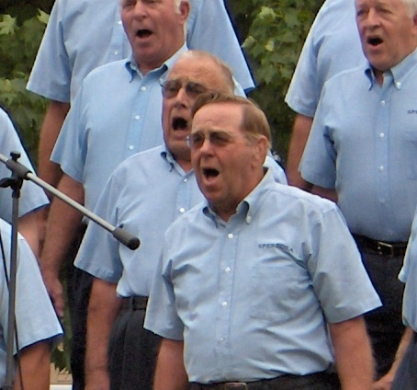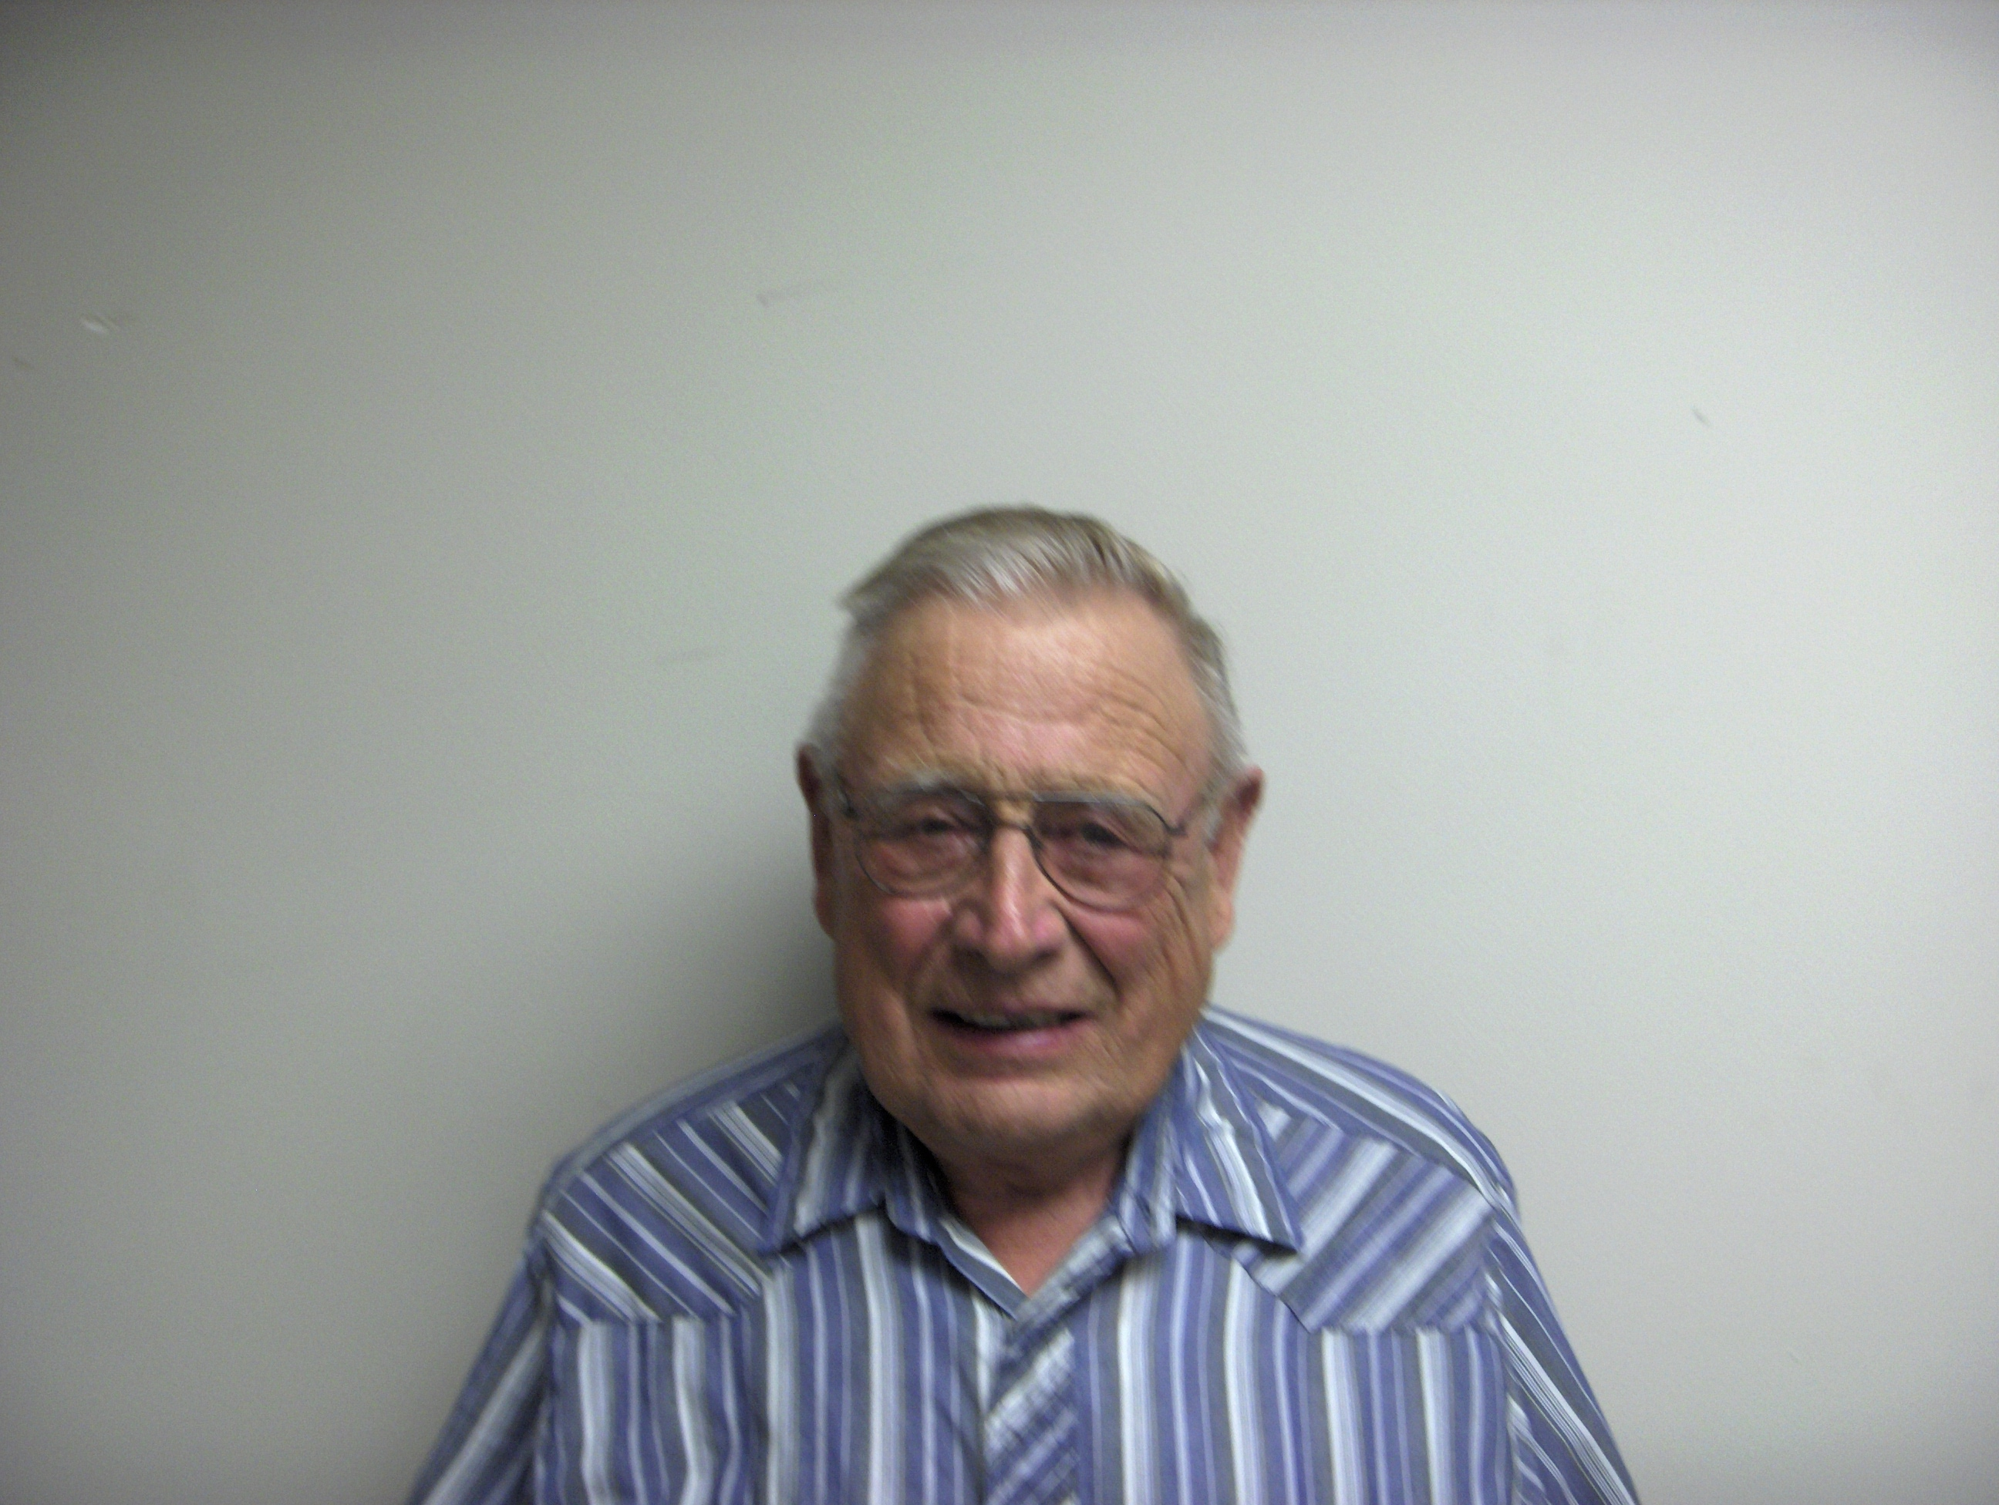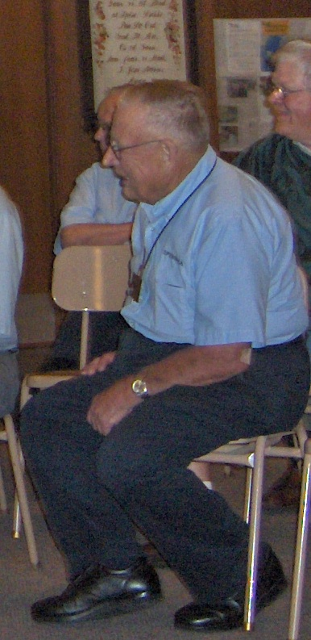
Definitions:

Happiness is not a station you arrive at, but a manner of traveling.
Suburbia is where they tear out the trees and name streets after them.
So far at Camouflage Training no one has turned up. Oh, wait a minute.

End of Mayan Calendar
Several thousand years ago...
Mayan one: "Okay guys I've finished the calendar!"
Mayan two: "But it only goes up to 21.12.2012"
Mayan one: "Ah don't worry about it we'll make a new one before then. I would have carried on this stone but I ran out of room."
Mayan two: "Fair enough. Hey, imagine if people thought that the world was gonna end because you couldn't find a bigger stone."
Mayan one: "Yeah, but you'd have to be pretty stupid to think that wouldn't you?"

LIVE, LOVE, LAUGH. Life’s a gift. That's why it's called PRESENT ... UNWRAP IT! Have a Blessed day and a Blessed year!

